Bachelor of Arts in Theatre, Film and Television

to Be Offered by IUPUI-SLA at Indianapolis
February 2020

Characteristics of the Program

  - Campus Offering the Program: Indiana University–Purdue University Indianapolis

  - Scope of Delivery: IUPUI (School of Liberal Arts) at Indianapolis

  - Mode of Delivery: Primary mode of delivery is classroom instruction. Some courses will be offered online or in a hybrid format.

  - Other Delivery Aspects: High impact learning opportunities for students in this major include internships, community engagement, student research, study abroad, and independent study courses. As part of their program of study, students will develop an ePortfolio, which will be completed in the Capstone course.

  - Academic Unit Offering Program: IUPUI School of Liberal Arts. The Departments of Communication Studies and English are primary contributors to this major. Many other departments both within Liberal Arts and in other Schools (Informatics, Herron School of Art, Engineering and Technology) are contributing courses to this major.

  - Anticipated Starting Semester: Spring 2021

2. Rationale for the Program

a. Institutional Rationale

The Theatre, Film, and Television (TFT) major represents a comprehensive and logical nexus of three related humanities-based arts disciplines which are currently distributed across several departments in the IU School of Liberal Arts (SLA) at IUPUI. It provides a disciplinary home for theatre as both theory and practice, and leverages the strengths of SLA’s film and media studies curriculum, its numerous production courses, along with relevant and exciting media and theatre-related work being done in Herron School of Art, the School of Informatics and Computing, and the School of Engineering and Technology. This major features three distinct concentrations, the first in Theatre, the second in Film and Television Studies, and the third, an integrated concentration in film and television production and studies. There is no program like this in Central Indiana. Our Theatre concentration provides the only theatre curriculum on the IUPUI campus. Our Film and Television concentration offers students the choice of either a solely humanities-based film and television studies curriculum, or an integrated curriculum, which provides a firm conceptual basis for the practices that our production training then develops. This third concentration (as a B.A. degree) explores not only the technical skills of the media production process, but also emphasizes the understanding of film, television, screen and aural media. This is distinct from the Media Arts and Sciences (B.S.) major in the School of Informatics and Computing (SOIC), which has a much broader computing-based media production emphasis. At the same time, the film and television studies concentration offers a strong complement to the Media Arts and Sciences B.S. as an option in the Dual Degree Advantage initiative in the School of Liberal Arts. In the same way, this concentration also complements the Computer Graphics Technology major in the School of Engineering and Technology. The Theatre concentration will be appealing to students interested in a Liberal Arts/Herron School of Art dual degree.

Addressing a Need
By combining existing programs and providing them a more visible home, the TFT major addresses the persistent problems of disciplinary segmentation and lack of visibility that have been caused by housing related Liberal Arts disciplines in different departments. In doing so, we have inadvertently made our courses, majors, and minors difficult for students, advisors, and colleagues to find, both within our school and throughout IUPUI. We also have perhaps confused students and faculty outside our disciplines as to not only the rationales and traditions that distinguish our fields, but also the elements that unite them. Film Studies scholars in English and Media Studies professors in Communication Studies even belong to the same professional organization, the deliberately named Society for Cinema and Media Studies.

IUPUI is a large urban campus surrounded by a vibrant theatre community. Presently there are well over 30 industry recognized and producing theatre companies I the greater Indianapolis area, yet IUPUI lacks a Theatre program. The theatre major was discontinued in 1991, forcing students passionate about this art either to try to construct individualized majors or to attend other universities. While Communication Studies offers a Theatre and Performance Certificate as well as a minor in Theatre, these options do not provide the educational opportunities of a full-fledged major.

Finally, external reviews for the English and Communication Studies Departments have questioned how appropriate it is to place Media and Television Studies, Theatre, and Film courses exclusively in their respective departments. A 2013 External Review of the Communication Studies Department expressed concern that “the students . . . were unclear of the departmental focus and how theater and media were part of the undergraduate major.” The most recent External Review of the Department of English, also in 2013, stated, “film, especially, will need to explore interdisciplinary or collaborative models if it is to flourish” (boldface in original). We believe that our proposal provides clarity to the study of Film and Television, and Theatre in the School of Liberal Arts and the entire university. The innovative collaboration we propose offers students their choice of paths into Theatre and the study of film, television, and mass media.

A degree in Theatre, Film, and Television from the School of Liberal Arts will prepare students for a variety of professions following graduation. Careers in law, education, business, politics, public service, media industries, and even health and scientific fields, as well as the pursuits of theatre-related and film or media-oriented futures, can be built upon studies done in preparation for this degree. This major can lead to internships and prepare a student for graduate school.

Disciplinary Integrity
The major in Theatre, Film, and Television professionalizes three vital humanities disciplines that are central to the mission of the School of Liberal Arts. The Department of English currently offers a curriculum of Film Studies courses under the academic subject code, FILM. English also gives its majors the option of Film Studies as one of five concentrations in the English major, and provides a Film Studies minor as well. The Department of Communication Studies is the academic home for programs in Theatre and Media Studies. Students seeking courses and a program in theatre do not naturally look for these courses in a primarily social sciences-based Communication Studies department, and the same is true for Media and Television Studies. Communication Studies offers a selection of courses in Media theory, criticism, aesthetics, and history, as well as minors in Media Production and Media Aesthetics. Our proposed major would not affect the minors in either Film Studies or Media Arts and Studies. In an era of declining resources in SLA, bringing these programs together into one major would enhance these programs and be a great help to students looking for a coherent and comprehensive media-based curriculum.

The major in Theatre, Film, and Television emphasizes the study of theatre, dramatic literature, film, television, and media in all their aesthetic, historical, and cultural dimensions. It will help develop student understanding of these art forms in their interdisciplinary contexts, but with a special proficiency in at least one of these areas.
The major offers students a range of practical, critical, and research methodologies as well as playwriting, screenwriting, production, and for Theatre: both performance, and the application of theatre practice in applied settings.

The TFT major stresses the interdependence of artistic practice and intellectual knowledge. The Film and Television concentrations will teach students to recognize and analyze creative methods. Students will learn to know film and media as products of history, culture, ideology, industry and individual authorship. They then have the opportunity to incorporate this knowledge into their development of creative projects. Similarly, the Applied Theatre concentration combines the study of complex dramatic traditions and opportunities for students to learn performance and production, with pedagogies and coursework that prepares them to transfer the “gifts of theatre’ in interdisciplinary settings and nontraditional environments.

The number of credit hours for this major depends upon the specific concentration being pursued. The Applied Theatre concentration requires a minimum of 34 credit hours.
The Film and Television Studies concentration requires a minimum of 33 credit hours. The Integrated Film and Television Studies/Production Concentration requires a minimum of 37 credit hours. The curricular sequence for this major features a fundamentals course (COMM M150: Mass Media and Contemporary Society) which is common to all three concentrations. Students then have the opportunity to choose one of three concentrations (Applied Theatre, Film and Television Studies, or Integrated Film and Television Studies/Production. Finally, a unified capstone completes the major. The three concentrations are collaborative and multidisciplinary; they thrive in a liberal arts context that promotes breadth and integration of learning. They draw on courses not just in English and Communication Studies, but also American Studies, Medical Humanities, World Languages and Cultures, Journalism, Women’s, Gender and Sexuality Studies, and Africana Studies. The Integrated Film and Television Studies/Production concentration extends this interdisciplinary collaboration even further, by incorporating courses from SOIC, Computer Graphics Technology (CGT) and Herron School of Art.

THE MAJOR: Theatre, Film, and Television

THREE CONCENTRATIONS: Applied Theatre; Film and Television Studies; Integrated Film and Television Studies/Production

- Applied Theatre Concentration
Theatre in our school is laden with unrealized potential. It has been over 25 years since the School of Liberal Arts terminated the bulk of the school’s commitment to Theatre; the decision remains one of the most controversial acts in the history of the School of Liberal Arts. Indianapolis should feature at its heart a public university Theatre degree worthy of its bustling theatre scene. IUPUI’s recent partnership with the historic Madame C. J. Walker Theatre Center makes this the perfect time to reintroduce and rehabilitate theater in the life of the university and in our school’s curriculum. Theater can now become the stage on which Liberal Arts presents what our school has to offer to the university and civic community. Specifically, the Applied Theatre concentration would offer courses on acting, directing, and playwriting, while reintroducing long-dormant classes on other elements of stagecraft; these will be taught by existing full-time faculty. Moreover, recognizing the power theatre has to evoke social change, this concentration would weave civic engagement into the curriculum. We will be working with the Africana Repertory Theatre Initiative (ARTI). ARTI is in the process of developing a program that may include a minor or certificate in African-American Theatre. These offerings, together with English courses in Drama, will give undergraduates interested in Theatre a comprehensive knowledge and understanding of their discipline with an “applied theatre lens” that presently exists (perhaps unknowingly) on campus in many forms: Standardized Patient Care in IUPUI’s School of Medicine; The Tunnel of Oppression sponsored by the Social Justice Scholars; the use of drama and playwriting in IUPUI’s Occupational Therapy Program; the use of mock trials in the Criminology Program and within case studies in the School of Law; Arts Integration Initiatives that make curricular content accessible to diverse learners and improve pedagogies used by future teachers enrolled at the School of Education; even workshops posted across campus that utilize “Dramatic Improv” to teach life lessons and/or create engaging ice-breakers for any number of learning communities and social organizations on campus.

We anticipate collaboration and buy-in with all of these aforementioned extensions of Applied Theatre craft on campus in a relationship of elegant reciprocity, that activates embodied learning outcomes, fosters dialogue and provides opportunities for students pursuing this major to develop and master their art.

Applied Theatre is a relatively new term that has emerged in popularity since the end of the 20th century to describe a spectrum of diverse theatrical practices in community, educational or therapeutic contexts. Applied theatre praxis takes on a wide variety of forms: Scripted, unscripted, improvisational, scripted play development, devised performances, indigenous forms of cultural performance, innovative hybrids with new forms of digital communication, along with many other genre-defying forms.

Despite its variety, three common and critical factors identify most Applied Theatre practice. First, it happens in non-conventional theatre spaces and social settings (e.g., schools, prisons, streets and alternative educational provisions.) Second, its primary intention is to generate change (of awareness, attitude, behavior, etc.) towards some “thing” (goal, objective, social/political issue, etc.) Lastly, it requires and invites the active participation of an “audience” by being responsive to the stories of conventional people and giving them agency and artistry to challenge, question and re-envision via the theatre medium.

Our Applied Theatre concentration is designed to accommodate students who wish to align and apply theatre craft with interests in career goals and fields such as community organizing, counseling, criminal justice, education, law, management, medicine, public service, social services, social work, etc. The program will prepare students for graduate studies in applied theatre, drama therapy, theatre performance and any number of related areas of study where being “artistic agents of change in education, inclusivity and social justice initiatives” can intersect with theatre praxis.

B) Film and Television Studies Concentration
Those involved in the crafts, the technologies, and the business of media, should have a critical understanding of film and television as art and artifact, as well as a learned capacity for writing, analysis and interpretation. Practitioners should know the criticism, theory, and history of film and media; conversely, those interested in becoming critics, scholars, and curators should have at least an understanding of the life behind the camera and in the editing room.

This concentration within the major in Theatre, Film, and Television will train students to apply a knowledge of film and media history and analysis to a variety of media and communications industries. The program will also act as a resource for the university and the community. Students will participate in the cultural life of Indianapolis and the state of Indiana through institutions such as the Indianapolis Museum of Contemporary Art, the Indianapolis International Film Festival, the Heartland Film Festival, the Eiteljorg Museum, Indianapolis Short Film Festival, local broadcast television and radio stations, as well as various local school districts. Graduates with a degree in Theatre, Film, and Television can expect to qualify for positions with film and media companies, film archives, museums, video production houses, as well as media production facilities in a variety of life science organizations.

C) Integrated Film and Television Studies/Production Concentration
This concentration affords students the opportunity to specialize in production of television or digital film and video, in the contexts of historical, theoretical, cultural, and aesthetic studies of these arts.∗ The concentration supplies its majors with solid instruction and production experience from four IUPUI schools: the School of Liberal Arts, School of Informatics and Computing, the School of Engineering and Technology, and the Herron School of Art. It provides courses in history, theory, genres, great directors, and other issues vital to comprehensive studies in the aesthetic and cultural richness of these arts, in addition to a thorough familiarity with their practical workings. Majors who opt for the production concentration will emerge with industry expertise as well as awareness of historical and cultural subtexts, not to mention critical and aesthetic skills. The production concentration provides students with the best of four schools and of several broad-based approaches to media education—the hands-on methods taught by an arts-oriented school, and the cultural and analytical orientations of a school of the humanities and social sciences. Therefore, the production concentration in the TFT major offers a necessary third option in a program designed to inculcate in media-minded students an appreciation of interdisciplinarity and intermediality for our time and the future.

Alignment of Goals
The major in Theatre, Film, and Television represents a meaningful and substantial articulation of the mission of the IU School of Liberal Arts at IUPUI, which is to “create and exchange knowledge that promotes understanding of the human experience.” The major in Theatre, Film and Television is keenly tied to the modes of communication that have become the principal carriers of meaning in our society. Our proposal aims to teach students ways in which the aesthetics of Television, Film, and Theatre are understood and appreciated by individuals and audiences. It looks at the history of these forms in an effort to understand how they came to dominate the aesthetic landscape of our society. It also demonstrates the role in society today of theater, film, and television, and teaches students how to examine and evaluate their power and influence in our ever-changing social order.

The arts are indispensable in the world. They have historically been bulwarks against fascism. An understanding of the role of the arts in society is critical for all citizens. They represent perhaps the most complex expression of creativity in our society. The arts can also be used to repress and destroy. It is imperative that citizens understand fully the power of the arts. In today’s society the dominant, ubiquitous art forms are film, television, and theatre. The major in Theatre, Film, and Television will equip students with a comprehensive understanding of the forms of communication and aesthetics that pervade our culture. Students will learn to examine, critique, and analyze these forms of expression. They will also be in a position, if they so choose, to create mediated content which is attuned to the lofty goals of democracy and civil society. As mentioned previously, the Applied Theatre concentration within the TFT major, even goes one step further by inviting students to utilize these essential understandings that align with the School of Liberal Arts’ mission and take action with their artistry and knowledge.

Demand
The student populations we target for this major, are the following:
  - Students with an interest in Theatre.
  - Liberal Arts students with an interest in humanities-based approaches to the study of aesthetic forms such as theatre, media, television, and film.
  - Students who want to combine their knowledge of humanities-based approaches to the understanding of aesthetic forms, with the skills and knowledge needed to produce content in a variety of media and theatre contexts.
  - Students in other schools and programs who may want to utilize the “Liberal Arts Dual Degree Advantage” to create double majors in TFT and their own primary majors. This should be particularly attractive to Informatics, Media Arts and Sciences majors, as well as some students in Computer Information and Graphics Technology, Music and Arts technology, and Visual Communication Design or the Kelley School of Business.

We anticipate that this major will grow steadily as marketing, promotion, and word of mouth alert potential students to the opportunity. There are currently over 300 students on the mailing list of the campus Theatre Club. Theatre courses enroll approximately 100 students each semester. Media Studies courses within the Department of Communication Studies enroll approximately 130 students each semester. Film Studies courses in the English Department enroll approximately 120 students each semester. The Film Society at IUPUI currently has 90 student members. This critical mass represents an excellent starting point from which to launch the program.

- In their contemporary connotations, the words “film” and “video” designate works that are made (as in “short film” or “YouTube video”), and not the media platforms on which they are produced.

b. State Rationale

The agenda set forth by the Indiana Commission for Higher Education in Reaching Higher, Achieving More emphasizes the need for colleges and universities to increase efforts to ensure that we are meeting the needs of students and the state. We in higher education need to be student centered, mission-driven, and workforce-aligned. We need to increase the number of students we serve. We need to ensure that they are able to complete degrees in a timely manner.

The degree proposed here aligns with these goals. As stated by the commission, “to achieve a better result, Indiana and its higher education institutions must respond to changing times and growing demands [and] rethink traditional notions and approaches...” Currently, Indiana ranks 40th nationally in higher education attainment, and 41st in personal per capita income. For us this means a state full of untapped potential.

In addition, the commission seeks to reward policies and programs where Indiana’s institutions of higher education “relentlessly pursue opportunities to create efficiencies,” while embodying the value of continuous efficiency. It states that it will champion actions that “emphasize high-quality instruction as the central priority” where “resources are aligned accordingly.” (p. 17) Such an alignment and creation of efficiencies is exactly what is embodied in this proposal-- creating an efficiency of opportunity with pre-existing resources, while ensuring high quality instruction. This major will reinvigorate several disciplines, which have until now, been dispersed throughout the school and campus.

Nationally, programs in film, television, media studies, and theatre are often among the most popular of majors. At the center of the degree in Theatre, Film and Television, is a commitment to a Liberal Arts core, and to developing a knowledge base and set of skills central to our information and media-driven society. Telling stories both visually and aurally plays an ever-increasing role in our society and in our economy. Americans spend more time than ever watching videos, browsing social media and swiping endlessly on tablets and smartphones. American adults spend more than 11 hours per day watching, reading, listening to or simply interacting with media, according to a recent Nielsen survey -- up from nine hours, 32 minutes just four years ago. Television still accounts for most media usage, with four hours 46 minutes spent watching TV every day (in 2018). An appreciation for the power, impact, and potential of media in this environment is key to using this power productively and ethically. Understanding and being able to use media as taught within a liberal arts setting, will provide students with the critical thinking, problem-solving and communication background to help shape the media industries in which they’ll be employed.

While media-related academic programs are often limited to and focused on producing content, our aim with the major in Theatre, Film and Television, is to understand and appreciate these aesthetic forms, critique their ubiquitous and dominant position in the social order, examine their modes of meaning construction, and address the ways in which they came to dominate meaning-making, art, and communication in our culture. This major will graduate students who will not only be able to produce content (in both media and in theater), but also be able to articulate reasons for its draw on our culture and its role in society. This will undoubtedly lead to better content in both applied theatre and media.

We anticipate a vibrant major that will provide students with numerous paths to timely completion of their degrees. The B.A. degree in Theatre, Film, and Television will provide employment opportunities in both media-related businesses and industries, as well as opportunities shared by other liberal arts majors. Elsewhere in this document, we highlight statistics (drawn from the U.S. Department of Labor) that demonstrate how skillsets and knowledge central to the B.A. degree in Theatre, Film and Television, provide for better job outcomes in Indiana than in other states. We should also not underestimate the “career readiness” aspect that is nurtured in the Applied Theatre concentration, where degree recipients will be equipped with diverse skillsets and diverse practical experiences that expand the potential for better job outcomes directly related to their chosen field as they literally “apply their art form” in practical and essential contexts. These clearly speak to Reaching Higher, Achieving More’s call for mission driven systems of higher education that “each fill a distinct but integrated role” and a system that is workforce aligned by “recognizing the increasing knowledge, skills and degree attainment needed for lifetime employment and ensuring Indiana’s economic competitiveness.” (p.4)

c. Evidence of Labor Market Need

- National, State, or Regional Need
A degree in Theatre, Film, and Television from the School of Liberal Arts will prepare students for a variety of professions following graduation. Careers in law, education, business, politics, public service, media industries, and even health and scientific fields, as well as the pursuits of theatre-related and film or media-oriented futures, can be built upon studies done in preparation for this degree. This major can lead to internships and prepare a student for graduate school. In 2017, the Chronicle of Higher Education conducted a survey of college and university leaders and employers, who were asked what three specific skills recent college graduates most need to be successful. While relevant technical skills came in second (40%), first (45%) were communication skills. Third were problem-solving skills. The three concentrations in this major, place a heavy emphasis on these skills. Within a liberal arts setting, problem-solving is a key component in baccalaureate competencies. An emphasis on communication skills, competencies and knowledge is inherent in a major that includes both theatre and media. Media studies is routinely viewed (as is currently the case at IUPUI) as a part of the Communication discipline. At many schools this is the case with Film and Cinema Studies as well.

In terms of State and Regional need, statistics compiled by the U.S. Department of Labor, Bureau of Labor Statistics indicate that most job categories connected to media studies and media production should over the next decade experience average to above average growth. However, in Indiana that growth is consistently projected to be higher than the national average. Specific figures highlighting this growth can be found in Appendix 4.

- Preparation for Graduate Programs
Upon completion of an IUPUI Theatre, Film and Television B.A. degree, students will be well prepared to enter graduate programs not only in these specific fields, but also in anthropology, communication studies, English, American Studies, criminal justice, geography history, law, political science or social work. The concentration in Applied Theatre pairs particularly well with the fields listed above.

Numerous graduate programs on the IUPUI campus can provide the next step for students interested in graduate education. The Department of Communication Studies offers an Applied Communication degree, in which students often focus on media arts and studies. The Schools of Informatics as well as Engineering and Technologies have related graduate programs, thus providing students a good and logical steps toward media related career goals that involve graduate work.

While there are few specifically Applied Theatre programs at the undergraduate level, this is a relatively new and developing field. There are a growing number of such programs at the graduate level, including the Masters in Social Practice Art at the University of Indianapolis. The development and growth in the number of these programs in recent years, points to their relevance and to the importance of this type of theatre as a way of addressing compelling social issues. In TCG (Theatre Communications Group) publication of Theatre Facts (2015) trends were evident where (of the over 100 theatres profiled among five distinct budget groups) an increasing number of income revenue was being generated from Education and Outreach programs, which means more job opportunities for individuals interested in working in these areas.

In terms of doctoral degrees, of 626 doctorates conferred in Communication studies nationally, in 2017, 36.9% were awarded in the Mass Communication/Media Studies specialization. An additional 34 were awarded in the Film/Radio/TV/Digital specialization.

- Summary of Indiana Department of Workforce Development and/or U.S. Department of Labor Data
According to the Bureau of Labor Statistics’ (BLS) Occupational Outlook Handbook, employment in Media and Communication is projected to increase by 4% from 2018-2028. This increase will produce approximately 27,600 jobs. The BLS attributes this growth to a greater need for creating, editing, translating, and disseminating information across a variety of platforms. The tables in Appendix 2 highlight job prospects in various theatre, media and film-related fields, and support the outlook expressed by the BLS. In addition, data from the handbook indicates that across almost all job categories for which national data is cited, the growth in those categories in the state of Indiana is expected to be higher than at the national level.
See Appendix 2: Summary of Indiana Department of Workforce Development and/or U.S. Department of Labor Data for additional detail.

- National, State, or Regional Studies
The National Center for Education Statistics 2018 report, The Condition of Education, revealed that the unemployment rate for 25- to 29-year-olds with bachelor’s degrees in Communication and Communication Technologies is the second-lowest among related fields (i.e., Liberal Arts and Humanities; Sociology; History; English Language and Literature; Political Science and Government), at 3.2%, behind only Political Science and Government, which showed an unemployment rate of 2.7 %. That same study showed that across all age categories, Communication and Sociology report the lowest unemployment rates, at 3.9%. Further, data from the Federal Reserve Bank of New York was used to compare the underemployment and unemployment rates of various bachelor’s degree holders in 2016-2017. Recent college graduates in Communication and Communication Technologies reported lower unemployment rates and lower underemployment rates than graduates in several similar humanities and social science disciplines (including Sociology, History, Political Science, Philosophy, Anthropology, English Language.

The Chronicle of Higher Education’s Almanac reported 2016-1017 median wages for early career graduates in Communication at $40,000, while mid-career wages increased to $70,000. A May 2018 Bureau of Labor Statistics report indicated that the media annual wage for employment in Media and Communication was $57,530, while the median annual wage for all occupations was $38,640. The Chronicle of Higher Education ranked Communication and Communication Technologies as 22nd of 55 majors on its 2016-2017 list of Highest Media Wages at Mid-career by Major.

Numerous opportunities exist for students interested in theatre and in using theater in applied settings.
A recent survey of employers done by the Association of American College and Universities (Liberal Arts Graduates and Employment: Setting the Record Straight) found that employers want all students to study the liberal arts and sciences. Four out of five employers agree that all students should acquire broad knowledge in the liberal arts and sciences. 93% of employers agree that candidates’ demonstrated capacity to think critically, communicate clearly, and solve complex problems is more important than their undergraduate major.

Not only will graduates of the TFT program qualify for numerous media related careers (as cited in appendix 4), their knowledge will also qualify them for numerous opportunities in other fields that value a liberal arts education. The survey cited above also highlighted the top 15 professions of Liberal Arts graduates. These include teachers, lawyers, managers, chief executives and legislators, education administrators, social workers, counselors, sales representatives, clergy, retail sales supervisors, administrative assistants, accountants and auditors, and marketing and sales managers.

See Appendix 3: National, State, or Regional Studies for additional detail.

v. Surveys of Employers or Students and Analyses of Job Postings

See Appendix 4: Surveys of Employers or Students and Analyses of Job Postings for additional detail

vi. Letters of support
Letters of support contained in this proposal come from two sources. Letters from community organizations address the need for this major. Most important are those from theatrical organizations which speak to the need for a program in theatre. Second source of letters in support of this major come from other schools at IUPUI who might be affected by this major. These include letters from the Deans of the Schools of Informatics and Computing, Herron School of Art, and Engineering and Technology.

See Appendix 5: Letters of Support.

3. Cost of and Support for the Program

- Costs

i. Faculty and Staff
The School of Liberal Arts recently hired a full time faculty member to guide the development of the concentration in Applied Theatre. There are two courses that would need to be developed (within the first 2 years, a foundational 200-level course in the Applied Theatre). We will also be developing a bridge experience (at the 200 level) as an internship in the theatre concentration. The rest of the courses in this curriculum are already being offered. Since the proposed courses are already taught, we anticipate no new hires besides the Department of English’s long outstanding request to hire a replacement in Film Studies, a line currently filled by a visiting faculty member. We anticipate that this hire will be able to also teach television/media studies courses. Since the School of Liberal Arts has moved to a shared services model of administrative support, there will be no need to hire a dedicated staff person to help with administrative functions.

See Appendix 6: Faculty and Staff for additional detail.

ii. Facilities
Unless growth of the program exceeds expectations, additional financial, space or academic resources to support this program are not anticipated.

iii. Other Capital Costs (e.g., equipment)
We do not anticipate equipment costs over and above normal wear and tear, replacement costs associated with media production equipment and theatrical supplies and equipment. Upgrades to all equipment triggered by changes in technology can eventually be expected.

b. Support
i. Nature of Support (New, Existing, or Reallocated)
The School of Liberal Arts recently hired a full time faculty member with expertise in Arts Integration practices, curricular design, the training of teaching artists and Community Outreach to guide the development of the concentration in Applied Theatre. Other new courses included in this major are an Internship course and Independent Study. All other courses involved in this proposal are already being offered. Since the proposed courses are already taught, we anticipate no new hires besides the Department of English’s long outstanding request to hire a replacement in Film Studies, a line currently filled by a visiting faculty member. Since the School of Liberal Arts has moved to a shared services model of administrative support, there will be no need to hire a dedicated staff person to help with administrative functions.

ii. Special Fees above Baseline Tuition
We anticipate the continuation of Lab fees that are already in place in theatre and media production courses, as well as in film studies courses.

Similar and Related Programs

  - List of Programs and Degrees Conferred

i. Similar Programs at Other Institutions
A major such as we are proposing is not offered on either the IUPUI or the IU- Bloomington campus. IU-B’s Media School offers a major that combines humanities- based approaches to production. The TFT major is built around Film and Television as a humanities-based academic discipline, as well as a mode of communication and art form. The Integrated Film and Television Studies/Production Concentration expects equal attention be paid to students’ development of both production capabilities and an understanding and appreciation of film and television in their critical, historical and theoretical contexts. They will complete the program as far more than media technicians. Not only will be they be able to produce media content, they will bring to bear a greater depth and breadth of knowledge through which to understand the capabilities and potential of these media. Local institutions, including Butler, Marian, and University of Indianapolis do not offer film or television studies programs.

ii. Related Programs at the Proposing Institution
Related programs at IUPUI include the School of Informatics and Computing B.S. degree in Media Arts and Science. We have established a working relationship with this program. A sizable number of Informatics media production courses are offered as options in our Integrated studies/production concentration. Similarly, we have established relationships with Herron School of Art, the School of Engineering and Technologies’, Computer Graphics Technology and Music and Arts Departments, all of which are contributing coursework and support to this major. We are grateful to each of these programs for lending their support to the establishment of the major (letters of support can be found in appendix 5. These programs each have strengths that aren’t duplicative and that will provide our students with numerous options when developing their interests in television, film and theatre work.

Highly motivated students will find exciting opportunities if they choose to combine our concentration in Film and Television Studies (B.A.) with a Media Arts and Sciences B.S., or combine our major with one in Computer Graphics Technology through the School of Liberal Arts’ Dual Degree Advantage program. Our Applied Theatre concentration can be partnered with a Herron School of Art, or Education, or Social Work degree. These are just a few possibilities of combinations made possible by the Dual Degree Advantage initiative.

  - List of Similar Programs Outside of Indiana

The University of Notre Dame is the closest campus to IUPUI which has a Department of Theater, Film, and Media Studies. Their goals are similar to those which we envision. Their emphasis is “the history, theory, and study of theater, film, and screen media through practical experiences in production techniques and creativity.”

Other universities which offer the combination of art forms that we are proposing here include: St. Mary’s College of Maryland, University of Vienna (Austria), and University of York (UK).

The concentration in theatre is based around and limited to a focus on Applied Theatre. Undergraduate Applied Theatre Programs include the following:

In Canada:
University of Victoria; Cape Breton University; Brock University; University of Windsor

In the U.K.:
Birmingham City University; Goldsmiths University of London; London South Bank University; Northumbria University Newcastle; Royal Central School of Speech and Drama; The Liverpool Institute for Performing Arts; University of East London

In Germany:
University of Giessen

In the United States:
Drew University; Daemen College; University of Akron; Pacific University Oregon; University of Minnesota

  - Articulation of Associate/Baccalaureate Programs

See Appendix 9: Articulation of Associate/Baccalaureate Programs for executed articulation agreement for all three concentrations.

  - Collaboration with Similar or Related Programs on Other Campuses

No collaborations with programs on other campuses have yet been explored. We are certainly open to possibilities for collaborative work in the future.

Quality and Other Aspects of the Program

  - Credit Hours Required/Time to Completion

Appendix 10 lists the requirements for the major. The number of credit hours within the major varies by concentration. The Applied Theatre concentration requires a minimum of 34 credit hours. The Film and Television Studies concentration requires a minimum of 33 credit hours. The Integrated Film and Television Studies/Production concentration requires a minimum of 37 credit hours. In addition to the listing of requirements for each of these concentrations, Appendix 10 also includes degree maps for each concentration. These spell out how the major can be completed in four years (of full time work).

See Appendix 10: Credit Hours Required/Time to Completion for additional detail.

  - Exceeding the Standard Expectation of Credit Hours

This major will not require students to exceed 120 semester credit hours.

c. Curriculum, Program Competencies, or Learning Outcomes

The curriculum for the major in Theatre, Film, and Television is consistent with other humanities-based programs in the IU School of Liberal Arts at IUPUI. The major requires two core courses that are common to all three concentrations. The first of these is an introduction to the major. This course introduces the disciplines of film studies, television (often referred to as media) studies, and theatre. The course has two main goals: (1) to introduce basic theoretical concepts, critical methodologies, and areas of research, and (2) describe the major, distinguish and define the three concentrations, examine career possibilities, and construct potential plans of study for students. The second core course is a capstone. Taken in a student’s last semester, it will be a project-based application of principles, strategies, and skills learned throughout the major. In between these two “book-ends” students will follow one of three paths (concentrations), depending upon their particular interests. As they complete coursework, they will reflect upon their learning and attainment of appropriate learning outcomes through the construction of ePortfolios that will feature a wide variety of research creative artifacts that embody their mastery.

The degree maps located in Appendix 10 demonstrate not only ways in which students will be able to incorporate general education courses within their curriculum, but highlights ways in which they can attain their goals and complete their degree within four years. Appendix 10 also indicates all courses for which there are prerequisites, indicates the grades that must be maintained in the major, number of credit hours needed for each concentration, and number of credit hours in each concentration that must be taken at the 300-400 level. All of the requirements for each concentration can be successfully completed in four years. Furthermore, the articulation agreement with Ivy Tech indicates ways in which transfer students (with two years at Ivy Tech) will be able successfully complete their major at IUPUI in 2 years.

See Assessment section (below) for additional detail

d. Assessment
Assessment will closely track the program’s learning outcomes through performance in required courses and experiences and through entry and exit surveys. Program competencies and associated learning outcomes are aligned with the informed by IUPUI Profiles of Learning for Undergraduate Success (IUPUI+).

The program will track students’ success in obtaining jobs and employer satisfactions through surveys. We will also track alumni satisfaction through university sources such as IRDS.

Information gathered through the assessment process will be used to help determine the summative effectiveness of the program in meeting its intended learning outcomes and to inform any adjustments that are determined to be needed to help with continuous programmatic improvement.

Learning Outcomes in the Major in Theatre, Film, and Television | Where will students learn this knowledge or skill? | How will student achievement of the outcome be assessed? | Linked Profiles | In what setting will the assessment take place?
Apply theoretical constructs and critical frameworks in understanding describing or explaining) how meanings are co-constructed through theater, film and television | Courses: T100; T2xx; T130; T437; T305; C292; M215;T339; C391; T431; M462; internship; independent studies | Culminating project; exams; discussions; critical essays; portfolios, creative artifacts; productions; field observations; practicums and internships | Communicator (evaluates information)  Problem Solver (thinks critically, analyzes/synthesizes/evaluates) | Assessment will take place in courses, in high impact practice situations (internships, independent studies) and culminating capstone projects.
Identify and implement the basic techniques of visual and theatrical storytelling | Courses: T100; T130 T2xx; T339; T437; T431; T133; T333; T290; M210; M464; W302; W318; C292; M215; W250; M210; N420; M221; capstone | Culminating projects; critical essays; exams; productions; critical essays; portfolios, creative artifacts; field observations; practicums and internships | Communicator (builds relationships, conveys ideas effectively)  Problem Solver (analyze/synthesize/evaluate)  Innovator (creates/designs; makes decisions) | Assessment will take place in courses, in high impact practices such as service learning opportunities, internships) and in capstone projects.
Be able to demonstrate an appreciation of television, film, and theater as aesthetic forms | Courses: T100; T133; M150; T2xx; T130; 437; C310; L315; T337; T338; L370; T437; A460; C292; all film and television theory-history-criticism courses | Critical essays, research papers; exams, culminating projects; portfolios; creative artifacts; field observations; practicums and internships | Communicator (evaluates information)  Problem solver (thinks critically, analyze/synthesize/ evaluate) | Assessment will take place in courses, esp. through analysis of films, television and screen texts; theatrical performances.
Integrate collaboration and teamwork into the study and practice of theater, film and television | Courses: T130; T100; T339; T305; T333; A460; M221; N253; M210; M464; M465; M290; M466; capstone; independent study | Exams; group projects; discussions | Communicator (builds relationships, conveys ideas effectively, listens actively)  Problem solver (collaborates, perseveres)  Innovator (creates/designs; makes decisions)  Community Contributor (builds community, respectfully engages own and other cultures, anticipates consequences) | Assessment will take place in courses, in high impact practice situations (internships, independent studies) and culminating group projects and productions.
Critically assess ethical considerations in theater, film and television | Courses: M150; T2xx; T431; T305; T2xx(bridge); M215; M221; P355; M370; M373; J475; M420; I459 | Exams; research and critical essays; discussions; culminating projects | Communicator (builds relationships, listens actively)  Community Collaborator (respectfully engages own and other cultures, behaves ethically) | Assessment will take place in courses that include discussions of ethics.
Articulate one’s own cultural standpoint and how it affects appreciation or articulation of film, theater, and television | Courses: M150; T2xx(applied theatre); T431; T3xx (Theatre for social change); L379; M215; M373; C391; M462; J475; C299; C482; R350; W315 | Exams; research and critical essays; discussions; culminating projects | Communicator (conveys ideas effectively)  Community Contributor (respectfully engages own and other cultures) | Assessment will take place in courses; high impact practices such as independent studies, internships and capstone.
Additional Learning Outcomes for Applied Theatre Concentration
Utilize theater to respond to issues at the local, national, and/or global level | M150; T100; T130; T2xx: Fundamentals of Applied Theatre; T339; T437; T431; T3xx: Theatre for Social change; | Through theatrical performances; written plays; exams; class discussions. | Communicator (evaluates information, listens actively, builds relationships, conveys ideas effectively)  Problem Solver (collaborates, Analyzes/synthesiz-es/evaluates, perseveres)  Innovator (Creates/Designs, confronts challenges, makes decisions)  Community Contributor (builds community, respectfully engages own and other cultures, behaves ethically, anticipates consequences) | Assessed through critiques of theatrical performances; written materials; exams
Apply and develop theater craft and praxis to interdisciplinary settings and for informed use in nontraditional environments | T100; T130; T133; T437; T431; T333; T2xx; T339; T431; T3xx | Critical essays, research papers, exams, culminating projects, portfolios, performances, creative artifacts, productions | Problem Solver analyzes/synthesizes/ evaluates, perseveres  Innovator (Creates/designs; confronts challenges, makes decisions)  Community Contributor (builds community, respectfully engages own and other cultures, behaves ethically, anticipates consequences | Assessment will take place in courses, esp. through analysis of theatrical performances; assessment will also occur in high impact practices such as service learning opportunities; internships and in capstone projects.
Create aesthetically engaging and technically accomplished theatrical experiences, utilizing understandings of theater history and theory. | Courses: T100; T130; M150; C310; T337; T338; A460; T3xx: Theatre for Social Change; T100; T437; capstone; independent study | Theatrical productions; written plays. | Communicator (listens actively, builds relationships, conveys ideas effectively)  Innovator (creates/Designs, confronts challenges, makes decisions) | Assessment will take place in courses, in high impact practice situation (internships, independent studies) and culminating capstone projects. Assessment of theatrical skills
Additional Learning Outcomes for Film and Television studies Concentration
Value the importance of film and television history, theory, and criticism from a variety of perspectives | Courses: M150; C292; all courses in the theory-history-criticism category; courses in the cultural approaches category | Exams; critical essays; research projects; class discussions. | Communicator (evaluates information)  Problem Solver (thinks critically, analyzes/synthesizes/  evaluates) | Assessment will take place in courses, in high impact practice situation (internships, independent studies) and culminating capstone projects.
Produce research projects exploring topics in film and television, using theoretical, historical and/or generic approaches and knowledge sets | C350; C351; C352; C361; C362; C380; C390; C391; C392; C393; C394; C491; C493; M370; M373 | Term papers, midterm and final exams | Communicator (evaluates information) Problem Solver (thinks critically, analyzes/synthesizes/  evaluates) Innovator (creates/designs; confronts challenges, makes decisions) | Assessment will take place in courses, esp. through analysis of films, television and screen texts.
Demonstrate critical thinking skills by arguing persuasively, writing effectively, and thriving in a diverse world | C292;W260; C350; C351; C352; C361; C362; C380; C390; C391; C392; C393; C394; C491; C493; M215; M370; M373 | Response essays, critical reviews, 5 page essays; term papers, midterm and final exams | Communicator (evaluates information)  Problem Solver (thinks critically, analyzes/synthesizes/  evaluates) Innovator (creates/designs; confronts challenges, makes decisions) | Assessment will take place in courses, esp. through analysis of films, television and screen texts
Additional Learning Outcomes for the Integrated Film and Television Studies/Production Concentration
Value the importance of film and television history, theory, and criticism from a variety of perspectives | Courses: M150; C292; all courses in the theory-history-criticism category; courses in the cultural approaches category | Exams; critical essays; research projects; class discussions. | Communicator (evaluates information)  Problem Solver (thinks critically, analyzes/synthesizes/  evaluates) | Assessment will take place in courses, in high impact practice situation (internships, independent studies) and culminating capstone projects.
Produce research projects exploring topics in film and television, using theoretical, historical and/or generic approaches and knowledge sets | C350; C351; C352; C361; C362; C380; C390; C391; C392; C393; C394; C491; C493; M370; M373 | Term papers, midterm and final exams | Communicator (evaluates information) Problem Solver (thinks critically, analyzes/synthesizes/  evaluates) Innovator (creates/designs; confronts challenges, makes decisions) | Assessment will take place in courses, esp. through analysis of films, television and screen texts.
Demonstrate critical thinking skills by arguing persuasively, writing effectively, and thriving in a diverse world | C292;W260; C350; C351; C352; C361; C362; C380; C390; C391; C392; C393; C394; C491; C493; M215; M370; M373 | Response essays, critical reviews, 5 page essays; term papers, midterm and final exams | Communicator (evaluates information)  Problem Solver (thinks critically, analyzes/synthesizes/  evaluates) Innovator (creates/designs; confronts challenges, makes decisions) | Assessment will take place in courses, esp. through analysis of films, television and screen texts
Create aesthetically engaging and technically accomplished film and television content, utilizing understandings of film and media history and theory. | C292; M215; C391; M462; W302; W250; M221; N253; production electives | Culminating projects; critical essays; exams; class discussions, group work | Communicator (evaluates information, listens actively, builds relationships, conveys ideas effectively)  Problem Solver (collaborates, analyzes/synthesizes/evaluates, perseveres)  Innovator (Creates/Designs, confronts challenges, makes decisions)  Community Contributor (builds community, respectfully engages own and other cultures, behaves ethically, anticipates consequences) | Assessment will take place in courses, in high impact practice situations (internships, independent studies) and class projects; culminating capstone projects; acquisition of production skills

  - Licensure and Certification

This degree does not prepare graduates for a license or certification.

  - Placement of Graduates

Appendix 3 lists jobs in the following categories:
1) Jobs that are specific to students with major in Theatre. This also includes a list of theatrical organizations in the city (Indianapolis) and region (central Indiana).
2) Jobs that are specific to students with major in Film/Television Studies and production.
3) Jobs that are appropriate for Liberal Arts majors, such as those in the proposed major.
According to an AACU report, 93% of employers agree that candidates’ demonstrated capacity to think critically, communicate clearly, and solve complex problems is more important than their undergraduate major.

See job possibilities and links to resources in Appendices 2 and 3.

While this major is not necessarily a feeder for graduate programs, students completing the B.A. degree in Theatre, Film, and Television can expect to be able to continue their education in a wide range of graduate programs, including but not limited to:
- Film Studies M.A., Ph.D.
- Television Studies M.A., Ph.D.
- Media Studies M.A., Ph.D.
- Communication Studies M.A./M.S., Ph.D.
- English M.A., M.F.A., Ph.D.
- Media Arts and Sciences M.S.
- Theatre M.A./M.F.A.

  - Accreditation

There is no accreditation sought for this degree.

Projected Headcount, FTE Enrollments, and Degrees/Certificates Conferred

The Department of Communication Studies (the department which offers media courses and media studies and production minors and courses, minors, and a certificate in Theatre) has the largest number of majors (approximately 225) in the School of Liberal Arts. It offers a generalist undergraduate degree in Communication Studies, as well as a M.A. in Applied Communication, and a Ph.D. in Health communication. The Department of English (which offers Film Studies courses) has the second largest number of majors (approximately 175) in the school of Liberal Arts. A sizable number of majors in both programs have expressed an interest in a more targeted and specialized program in media and theatre. Film Studies currently has 15 minors, Theatre has 5 minors, and Communication Studies has 65 minors.

We anticipate that this major will grow steadily as marketing, promotion, and word of mouth alert potential students to the opportunity. There are currently over 300 students on the mailing list of the campus Theatre Club. Theatre courses enroll approximately 75 students each semester. Media Studies courses within the Department of Communication Studies enroll approximately 100 students each semester. Film Studies courses in the English Department enroll approximately 120 students each semester. The Film Society at IUPUI currently has 90 student members. This critical mass represents an excellent starting point from which to launch the program.

Core courses in this major are taught by approximately seven full-time faculty members in several departments in the School of Liberal Arts. Many more full-time faculty members from several schools and departments will teach elective courses. (See Appendix 6 for faculty involved in this major). Two core theatre courses are currently under development: T2XX: Fundamentals of Applied Theatre (3 cr.), and T2XX: Bridge Experience (1 cr.). T3XX: Theatre for Social Change (3 cr.) is an elective course that is also being developed. All other courses, both core courses and electives, are already being taught on this campus.

We anticipate that some current minors will become majors once this program is established. We also expect to gain majors once the name of the major is publicized. As stated above, students with interests in film studies, television, and/or theatre do not think that IUPUI has offerings in these areas, since these curricula are subsumed under broader programs. A five-year-out projection of 40 majors (15 majors in year 1 and additional 5 per year), does not seem unreasonable.

Appendices

Appendix 1: Institutional Rationale

Appendix 2: Summary of Indiana Department of Workforce Development and/or U.S. Department of Labor Data

Appendix 3: National, State, or Regional Studies

Appendix 4: Surveys of Employers or Students and Analyses of Job Postings

Appendix 5: Letters of Support Appendix 6: Faculty and Staff Appendix 7: Facilities Appendix 8: Other Capital Costs
Appendix 9: Articulation of Associate/Baccalaureate Programs

Appendix 10: Credit Hours Required/Time to Completion

Appendix 11: Details Related to Exceeding the Standard Expectation of Credit Hours

Appendix 1: Institutional Rationale
IUPUI Core: Vision, Mission, Values, and Diversity

https://www.iupui.edu/about/vision-mission.html

https://www.iupui.edu/about/diversity.html

Profiles of Learning for Undergraduate Success

https://profiles.iupui.edu/

RISE to the IUPUI Challenge

https://rise.iupui.edu/about/why-rise/index.html

The most innovative feature of this program is its collaborative nature. This major brings together the strengths of four schools (Liberal Arts, Informatics, Engineering and Technology, Herron), to provide students will the best opportunities for achieving their goals as they relate to the most dominant and pervasive communications forms in the world today. As the letters of support demonstrate, local and regional entities are excited by the prospect of this major.

Appendix 2: Summary of Indiana Department of Workforce Development and/or U.S. Department of Labor Data

Table 1: National Demand for Selected Occupations Related to Film, Media, Theatre, and Communication
United States Department of Labor Code | Occupations as Defined by the U.S. Department of Labor, Bureau of Labor Statistics | Employment, 2018 | Projected Growth* | Job Growth Rate, 2018-2028
27-4032.00 | Film and Video Editors | 40,000 | Much faster than average | 11%+
39-5091.00 | Makeup Artists- Theatrical and Performance | 5,000 | Faster than average | 7-10%
27-4031.00 | Camera Operators- Television, Video, and Motion Picture | 29,000 | Faster than average | 7-10%
27-2012.02 | Directors- Stage Motion Pictures, Television, and Radio | 152,000 | Average | 4-6%
27-2011.00 | Actors | 65,000 | Little or no change | -1-+1%
27-4011.00 | Audio and Video Equipment Technicians | 93,000 | Much faster than average | 11%+
25-4011.00 | Archivists | 8,000 | Faster than average | 7-10%
19-3093.00 | Historians | 3,000 | Average | 4-6%
27-3099.00 | Media and Communication Workers | 29,000 | Faster than average | 7-10%
27-1027.00 | Set and Exhibit Designers | 14,000 | Average | 4-6%
27-1014.00 | Multimedia Artists and Animators | 72,000 | Average | 4-6%
27-2012.05 | Technical Directors/Managers | 152,000 | Average | 4-6%
27-2012.03 | Program Directors | 152,000 | Average | 4-6%
25-1121.00 | Art, Drama, and Music Teachers- Postsecondary | 119,000 | Faster than average | 7-10%
25-9011.00 | Audio-Visual and Multimedia Collections Specialists | 11,000 | Average | 4-6%
*Growth Rate Definitions:
-1-+1%=little or no change|4-6%=average|7-10%=faster than average|11%=much faster than average

Table 2: Indiana- Statewide Demand for Selected Occupations Related to Film, Media, Theatre, and Communication
United States Department of Labor Code | Occupations as Defined by the U.S. Department of Labor, Bureau of Labor Statistics | Employment, 2016 | Projected Employment, 2026 | Job Growth Rate. 2016-2026
27-4032.00 | Film and Video Editors | 190 | 220 | +15%
39-5091.00 | Makeup Artists- Theatrical and Performance | 30 | 30 | +12%
27-4031.00 | Camera Operators- Television, Video, and Motion Picture | 290 | 310 | +7%
27-2012.02 | Directors- Stage Motion Pictures, Television, and Radio | 1,170 | 1,290 | +10%
27-2011.00 | Actors | 280 | 310 | +9%
27-4011.00 | Audio and Video Equipment Technicians | 970 | 1,090 | +13%
25-4011.00 | Archivists | 120 | 130 | +7%
19-3093.00 | Historians | 40 | 40 | +8%
27-3099.00 | Media and Communication Workers | 260 | 280 | +9%
27-1027.00 | Set and Exhibit Designers | 100 | 110 | +9%
27-1014.00 | Multimedia Artists and Animators | 390 | 410 | +6%
27-2012.05 | Technical Directors/Managers | 1,170 | 1,290 | +10%
27-2012.03 | Program Directors | 1,170 | 1,290 | +10%
25-1121.00 | Art, Drama, and Music Teachers- Postsecondary | 1,710 | 1,900 | +11%
25-9011.00 | Audio-Visual and Multimedia Collections Specialists | 210 | 230 | +8%

According to the Occupational Outlook Handbook, the media hourly wage for actors/theatre artists/media specialists was $17.54 in May 2018, which is above the average minimum wage. Growth in the number of Internet-only platforms may lead to increased work for actors/theatre artists/media specialists. Using these skills in unconventional settings (i.e., applied theatre) can only lead to more employment opportunities. Employment of producers and directors (whose median income was $71,680 in May 2018) is projected to grow 5% from 2018 to 2028. Job growth in the motion picture and video industry is expected to stem from strong demand from the public for ore movies and television shows, as well as an increased demand from foreign audiences for U.S.-produced films, which connects to all of these areas. (www.bls.gov/ooh)

Appendix 3: National, State, or Regional Studies

Liberal Arts Graduates and Employment: Setting the Record Straight, AACU:
https://www.aacu.org/sites/default/files/files/LEAP/nchems.pdf

“The State of the Communication Discipline,” Spectra: The Magazine of the National Communication Association, November 2019, Vol. 55, number 4.

“SCMS: The State of the Field of Film and Media Studies,” A Report on the SCMS Film and Media Studies Program Survey, December 2015.

U.S. Department of Labor site: https://www.onetonline.org/
U.S. Bureau of Labor Statistics site: https://www.bls.gov/bls/employment.htm

Results of other Studies
- According to Artists and Other Cultural Workers: A Statistical Portrait, a report by The National Endowment for The Arts, between 2016 and 2026, annual job openings will have averaged 7,400 for theatre artists and 14,100 for producers and directors. Employment growth in these occupations stems from strong demand for new movies and television shows. Employment of film/video editors is projected to grow at a 17 percent clip. A contributing factor is the number of shows increasingly produced by Internet-only sources and streaming services.

There are nearly 2.5 million artists in the U.S. labor force (either self-employed or wage-and-salary workers). Approximately 333,000 (self-employed or wage-and-salary) workers hold secondary jobs as artists, while another 1.2 million (self-employed or wage-and-salary) workers hold a primary job in a cultural occupation other than artist. Artists are 3.6 times as likely as other workers to be self-employed. In 2012-2016, roughly 34 percent of all artists were self-employed. This compares with 9 percent of all workers. Most self-employed artists seem to like their work arrangement: 79 percent say they would not prefer to work for someone else, while 58 percent cite flexible schedules and independence as the main reasons they are self-employed. Pursuit of this major and this degree facilitates autonomy and innovation in the work force, with the education, training and skills provided.

In 2006, artists composed 1.42 percent of the labor force; by 2017, they were 1.55 percent, representing a 6.1 percent increase. In 2017, the artist unemployment rate hit an 11-year low.

- Education Level of Artists Artists of all types are 1.8 times as likely as other workers to hold a college degree. 63 percent of all artists (aged 25 and older) hold bachelor’s degrees or higher levels of education. By comparison, only 36 percent of all workers in the labor force hold college degrees. Artists and Other Cultural Workers: A Statistical Portrait, a report by The National Endowment for The Arts,www.arts.gov

In 2015, the Indiana Arts Commission established Partnering Arts, Communities, and Education (PACE) to assist elementary schools and artists/arts organizations in establishing long-term, in-depth, and sustainable partnerships for the purpose of impacting student growth and achievement through extended and connected arts and literacy experiences. One of the recipients of this grant was the Arts Council of Indianapolis, who received a Theatre residency at James Russell Lowell (PS#51). The research findings of this initiative state-wide have been extremely positive and there is anticipated need of more individuals and a workforce to help facilitate these types of experiences with renewal of this program. In.gov/arts/files/IAC

- According to the INDIANA ARTS COMMISSION CREATIVE ECONOMY REPORT 2016, Indiana experienced growth in the number of self-employed individuals in Creative Occupations and Industries. Indiana has a greater proportion of self-employed members of the Creative Economy than the U.S. The top self-employed Creative Occupations and Industries in Indiana did not vary much across regions. This report provides a baseline for the State of Indiana answering questions such as: “How large is our creative industry?” “How does Indiana compare to national averages and trends?” “Where do our creative employees live and in what industries are they represented?” The answers to these questions provide a baseline for decision making for policy makers, employers, community leadership, and government on all levels, as together we aim to advance the appeal, stability and prosperity of Indiana’s economic and creative profiles.

- Indiana’s growth in self-employment in Creative Industries outpaced U.S. Creative Industry self-employment and self-employment in other Indiana industries. The industries with the largest proportions of creative jobs are in the information sector (83 percent). The information sector includes jobs related to publishing, broadcasting, and telecommunications. Arts, entertainment, and recreation (42 percent) provides facilities or services to meet recreational and cultural needs of individuals, and include professions related to sports, historical sites, and performing arts.

- Arts and Economic Prosperity® 5 was conducted by Americans for the Arts for the city of Indianapolis, the nation’s nonprofit organization for advancing the arts in America. AEP5 demonstrates that in the greater Indianapolis region and statewide that the arts provide both cultural and economic benefits. No longer do community leaders need to feel that a choice must be made between arts funding and economic development. Arts & Economic Prosperity 5 proves that they can choose both. Nationally as well as locally, the arts mean business.

This intensive study, Arts & Economic Prosperity 5 provides evidence that the nonprofit arts and culture sector is a significant industry in the City of Indianapolis—one that generates $440.5 million in total economic activity. This spending—$227.3 million by nonprofit arts and cultural organizations and an additional $213.2 million in event-related spending by their audiences—supports 14,729 full-time equivalent jobs, generates $361.7 million in household income to local residents, and delivers $47.7 million in local and state government revenue. This economic impact study sends a strong signal that when we support the arts, we not only enhance our quality of life, but we also invest in the City of Indianapolis’s economic well-being.

- An article published by HowlRound Theatre Commons (November 30 2017) states: “In many cities and states across the US, public universities anchor the arts in their communities, offering high-quality theatre and performance to communities where no professional theatres exist, or serving as a cornerstone for art makers to envision their own spaces supported by a University community . . . programs have begun to consider the interventions that their students might make in fields beyond the academy like arts administration, political advocacy, and publishing. In sum, they serve the national interest."

Possible jobs for graduates in Theatre, Film, and Television

Film and Video Editors

Camera Operators, Television, Video and Motion Picture

Directors (stage, motion picture, television and radio)

Actor

Audio and video equipment technicians

Archivists

Historians

Media and Communication Workers

Set and Exhibit Designers

Multimedia Artists and Animators

Technical Directors/Managers

Program Directors

Art, Drama, and Music Teachers, Postsecondary

Audio-visual and Multimedia collections specialists

Audio journalist

Columnist

Communications coordinator

Copy editor

Copywriter

Data journalist

Digital communications specialist

Digital illustrator

Director of photography

Documentary filmmaker

Graphics editor

Graphic designer

Information architect

Interactive designer

Marketing manager

Makeup Artists, theatrical and performance

Media Buyer

Multimedia journalist

Podcast producer

Public affairs specialist

Scriptwriter

Social media manager

Sound designer

Television anchor

Television producer

Video journalist

Videographer

Web designer

Theatrical Venues, companies, employers (Central Indiana)

Equity

Indiana Repertory Theatre

Phoenix Theatre

Actors Theatre of Indiana

Beef & Boards

Indianapolis Shakespeare Company

Shadow Ape

In-Between

Storefront Theatre of Indianapolis

Fonseca Theatre

Q Artistry

BobDirex

Summit

Catalyst Repertory Theatre

NoExit

BOLT

Khaos

Fat Turtle Theatre Company

Monumental

Catered Cabaret

Eclectic Pond

Acting Up

Wisdom Tooth Theatre Project

Community

Footlite Musicals

Assante Children’s Theatre

Belfry Theatre

Cat Theatre

Switch Theatre

Theatre at the Fort

Young Actors Theatre

Epilogue Players

Indianapolis Civic Theatre

Mud Creek

Buck Creek Players

Carmel Community Players

Westfield Community Theatre

Venues

Indy Fringe

District Theatre

National, State, and Regional Studies:
Media Studies: Media, Television
Bachelor’s Degrees Conferred by Specialty, 2016-17

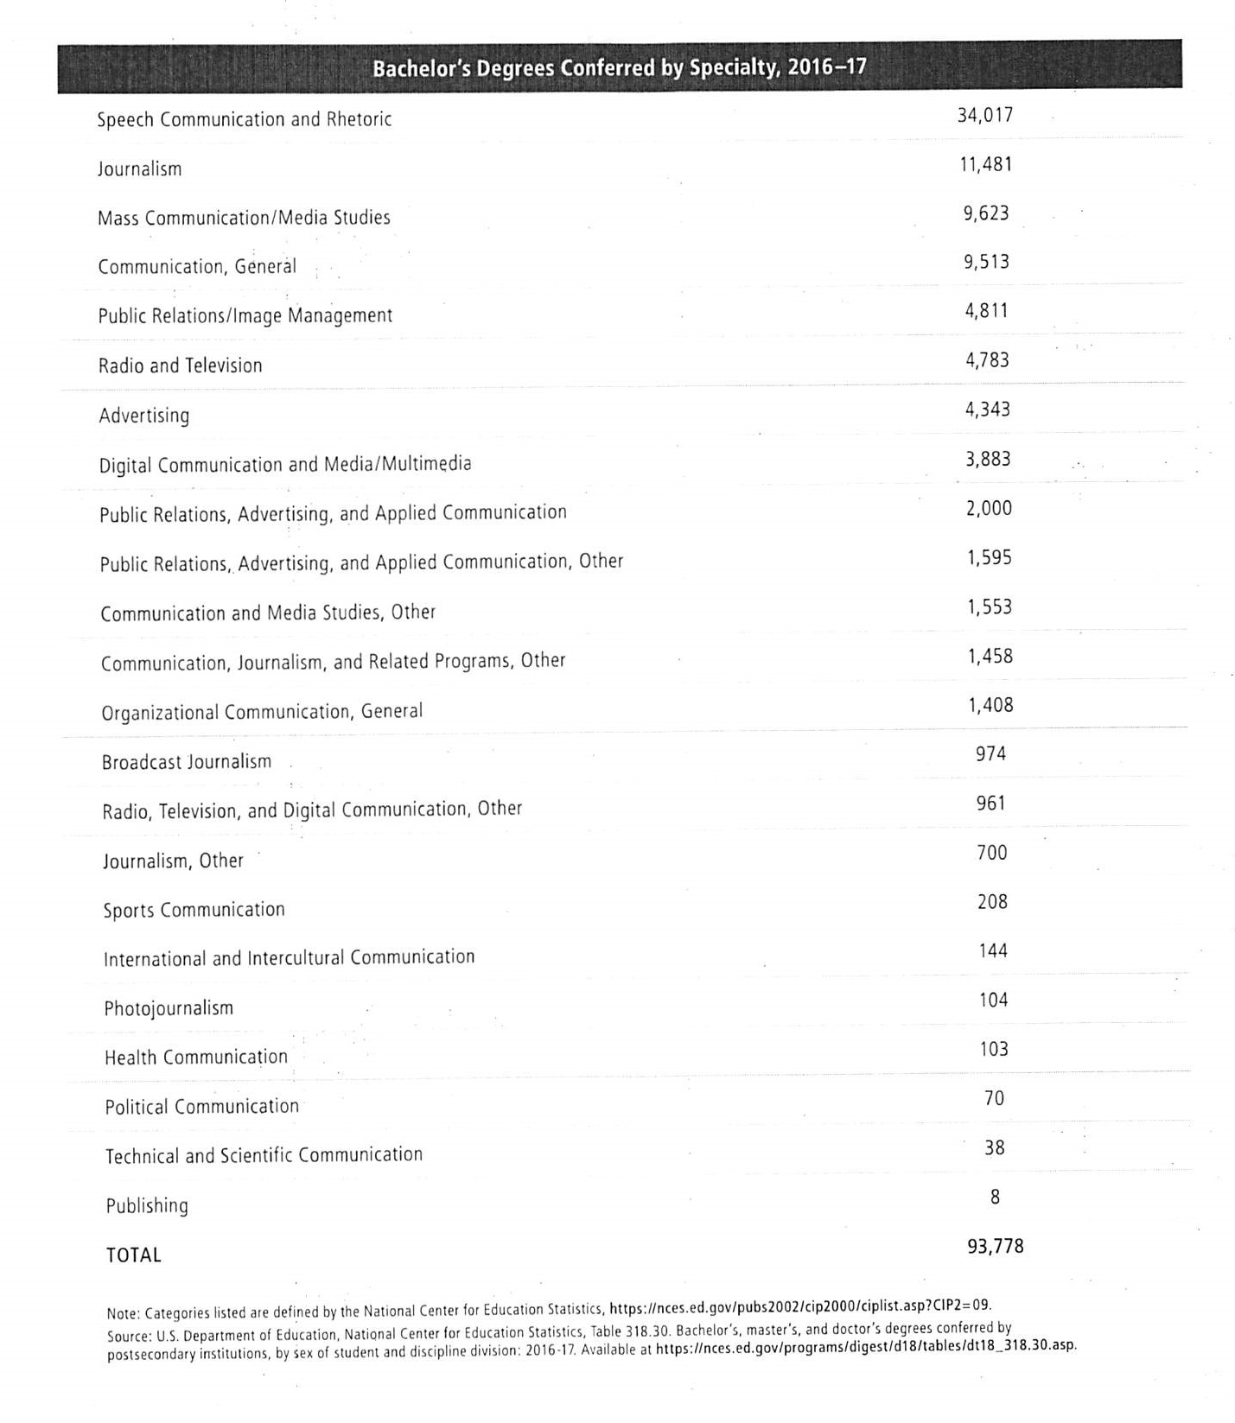

National, State, and Regional Studies:
Master’s Degrees Conferred by Field, 1970-71 through 2016-17

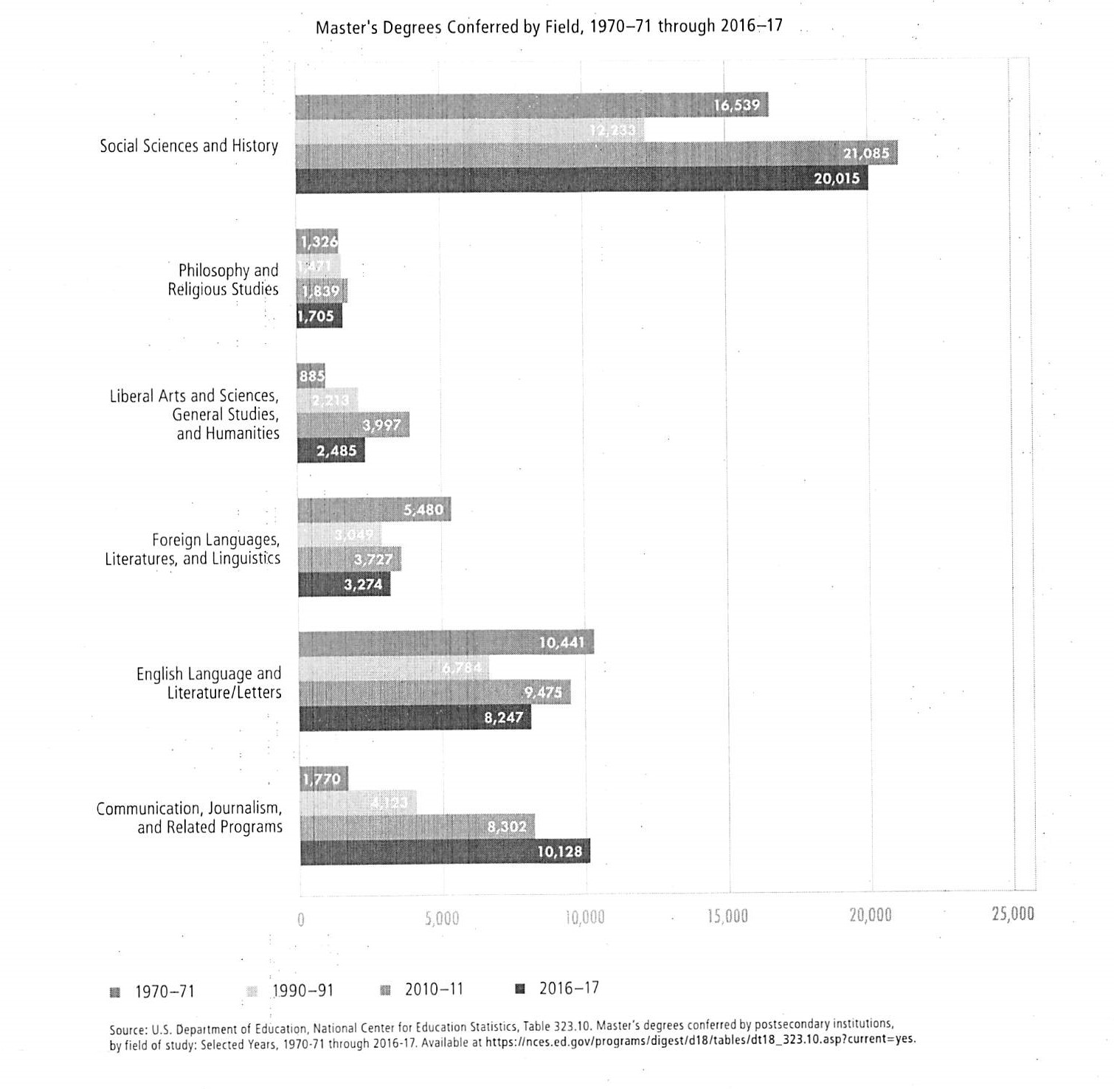

National, State, and Regional Studies:
Bachelor’s Degrees Conferred by Postsecondary Institutions, by Field

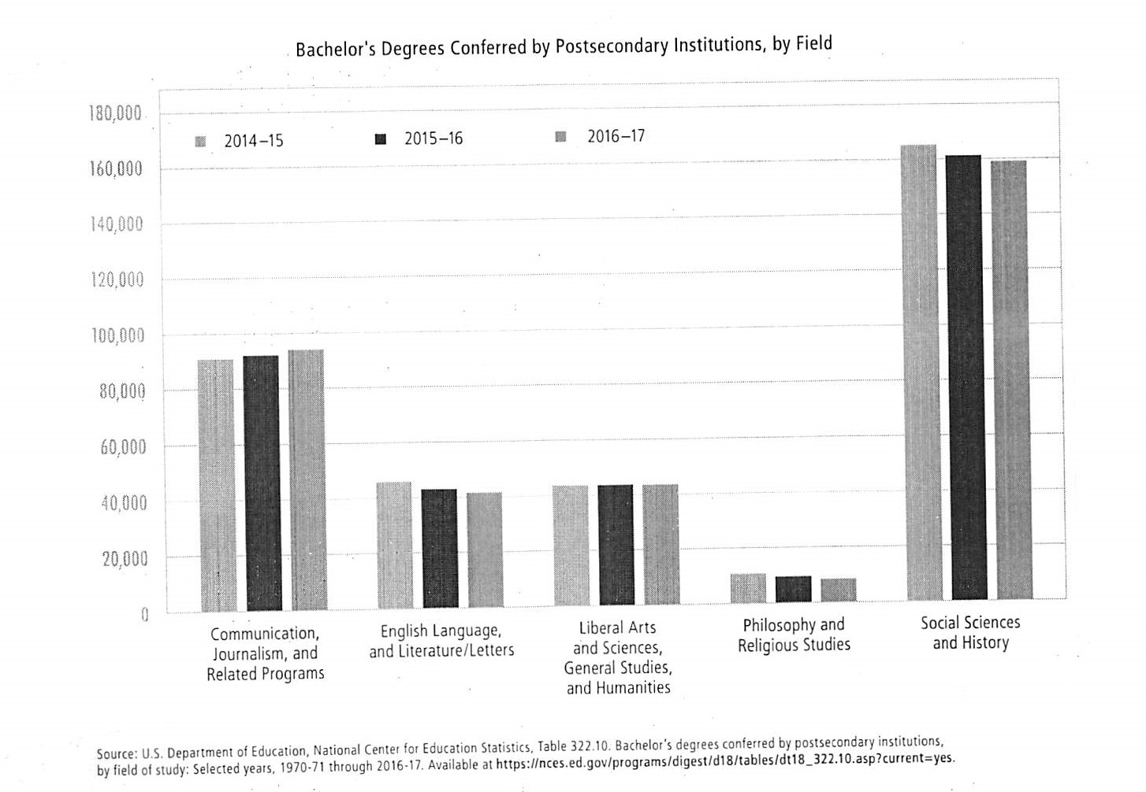

National, State, and Regional Studies:
Median Pay (2018) by Occupation

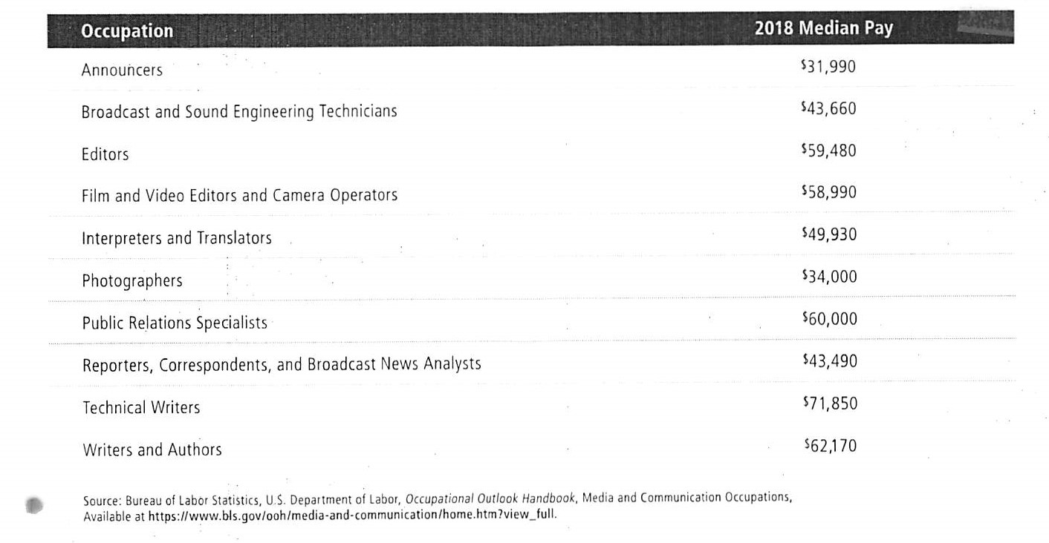

National, State, and Regional Studies:
Early and Mid-Career Media Wages, 2016-2017
Media Annual Earnings of 25-29-Year-Old Bachelor’s Degree Holders, by Field, 2017

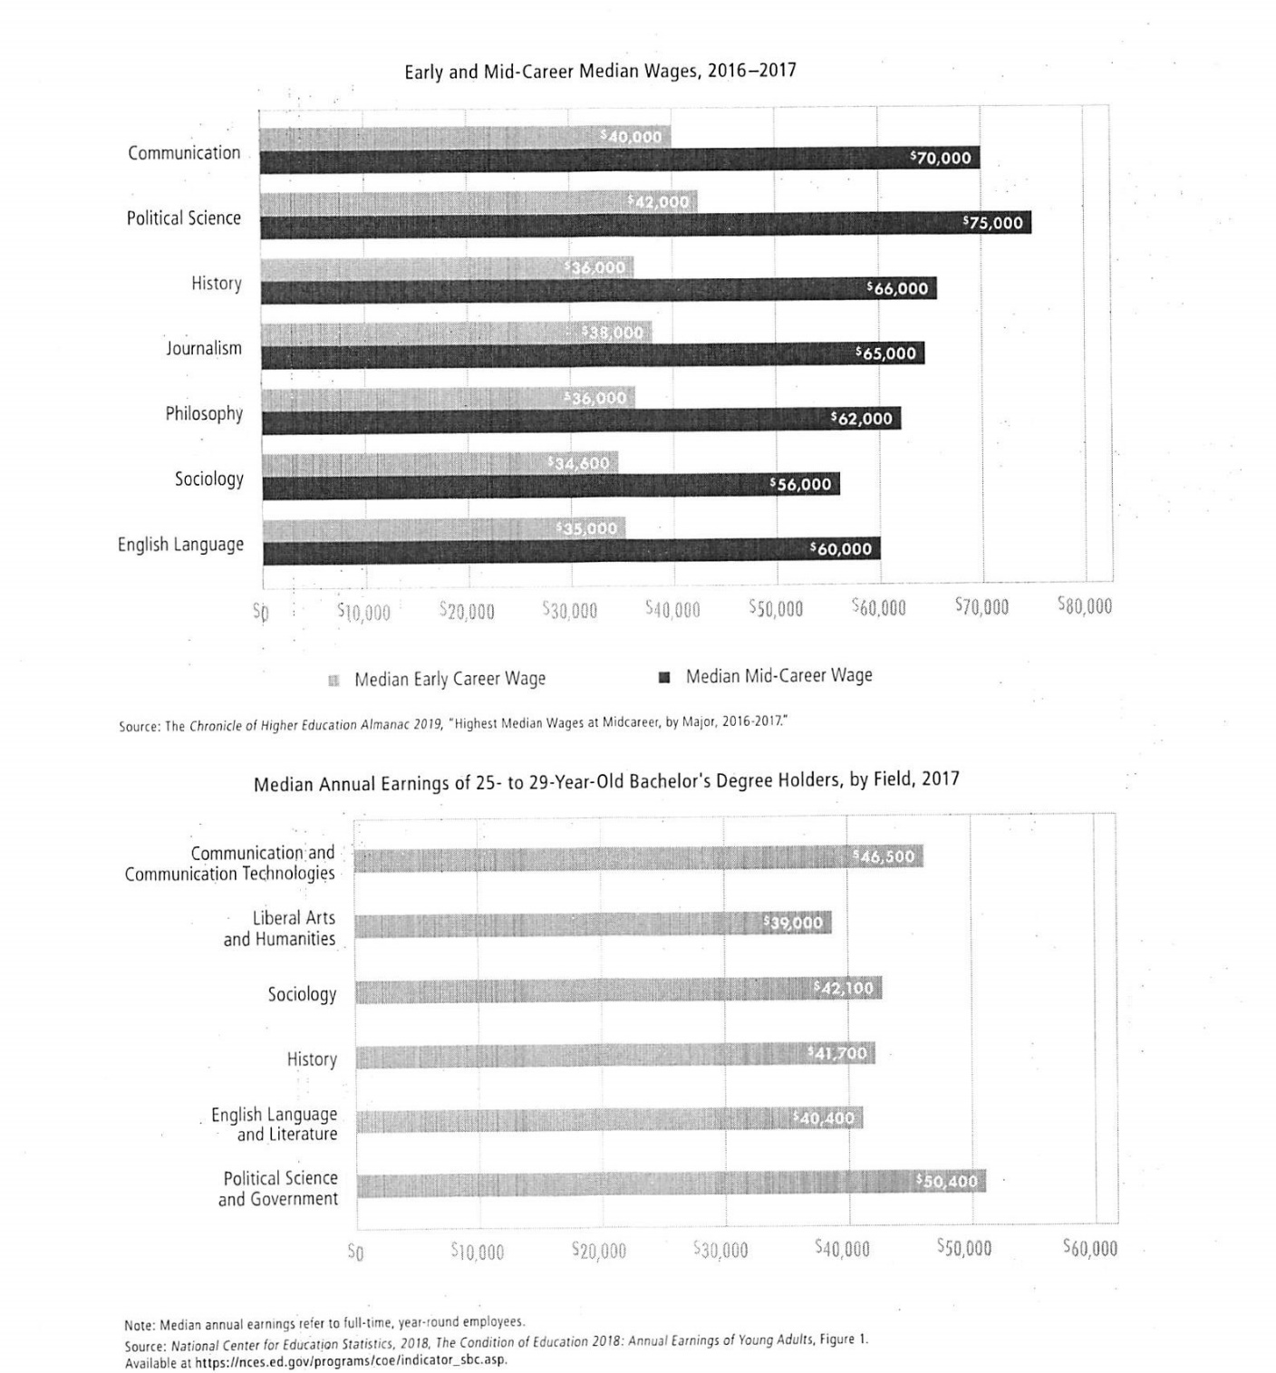

National, State, and Regional Studies:
Mid-Career Pay by Job Title

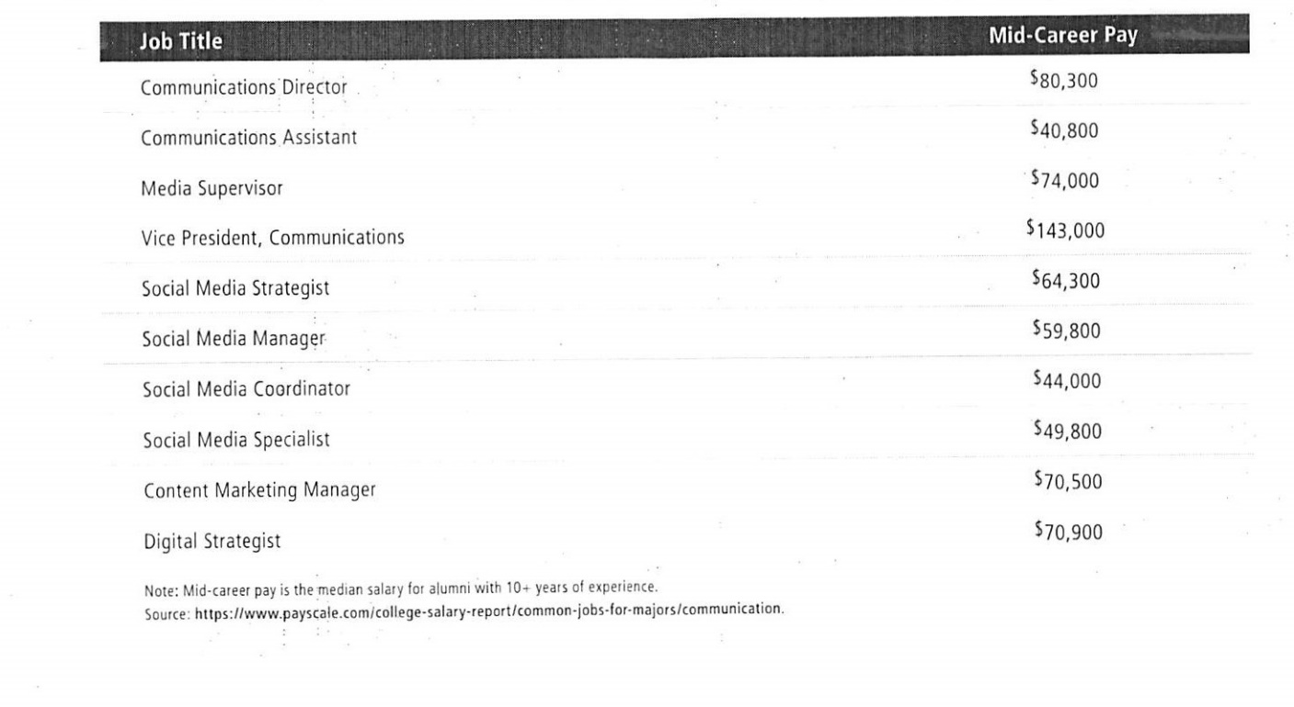

National, State, and Regional Studies:
Unemployment Rates of 25- to 29-Year-Old Bachelor’s Degree Holders, by Field, 2010 and 2017

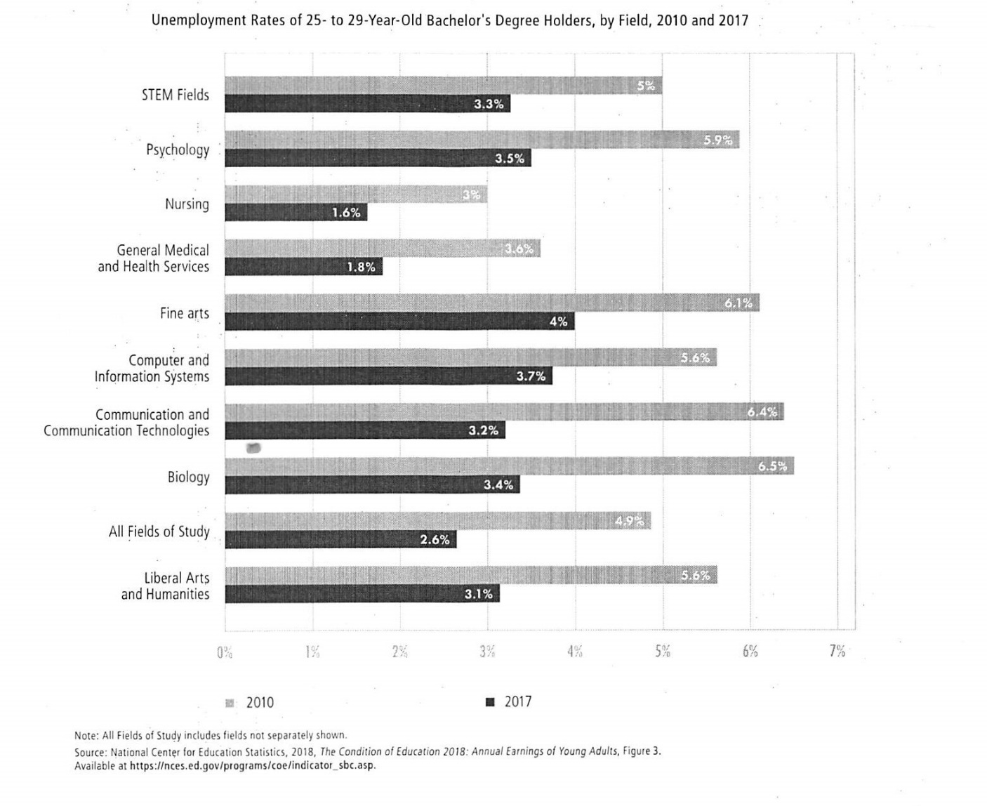

Appendix 4: Surveys of Employers or Students and Analyses of Job Postings

A very promising development in this field is the introduction of Indiana Senate Bill 262 that provides film and media production incentives. State Sen. Justin Busch (R-Fort Wayne) is the bill’s author. We are currently in the minority of states without such programs. Busch states that if enacted, this initiative “will help grow the state’s economy and keep talent in Indiana.”

Liberal Arts Graduates and Employment: Setting the Record Straight
Association of American Colleges and Universities, 2014.

A current issue of the IndyArtsGuide Employment Archive (1/29/20) listed over 20 postings with unfilled positions in areas that ranged from Applied Arts Instructors, Event Associates, Technical Directors, and Site Managers.

In a current listing on Indeed.com for “theatre-related jobs” in Indiana, there were 77 postings with jobs as a varied as Theatre Services Technician, Event Managers, Directors of Production, Box Office Staff and Arts Educators and Instructors at various levels.

Appendix 5: Letters of Support

The proposed major in Theatre, Film and Television has the potential to shift course enrollments within the School of Liberal Arts. It has the potential for increasing our number of Liberal Arts majors if students take advantage of “Liberal Arts Advantage” dual degree by combining our major with one in another school.

There are only two new proposed courses (in the Theatre concentration), neither overlaps in any way with existing courses, since there is no Theatre concentration elsewhere on this campus.

Courses required for the B.A. degree in Theatre, Film and Television that are taught outside of the major are open to all IUPUI students on a space-available basis, assuming they meet any course entry requirements, such as placement testing for English and mathematics and appropriate pre-requisites.

Robert Rebein
Interim Dean
IU School of Liberal Arts
IUPUI

Dear Dean Rebein,

I write to express my support for the new Bachelor of Arts degree in Theater, Film, and
Television to be offered by the IUPUI School of Liberal Arts. I believe this new interdisciplinary program has the potential to attract new students to IUPUI and SLA who will be eager to take advantage of the unique combinations of courses and skills that are available within the program. These new students should boost the enrollments in the English department courses in Film and Literature that are incorporated into the degree.

I understand that the proposal involves combining existing programs rather than creating a new program. The existing concentration in Film Studies within the English department, in slightly modified form, will be incorporated into the new interdisciplinary BA under the heading of its concentration in Film and Television Studies. Thus, once the new BA goes “live” (the projected date is Spring 2021) the Film Studies concentration within English will stop admitting new students.

My support for the new BA is also based on the assumptions that (a) current students in the Film Studies concentration in English will be able to complete their programs without any changes or interruptions; (b) there will be no change to the existing minor in Film Studies within the English department; (c) Dennis Bingham and his faculty line in Film Studies will remain within the English department (i.e. Dennis’s academic “home” will remain in English); (d) all English department courses offered as curricular choices or requirements in the new program, and the credit hours they generate, will remain within the English department.

Please let me know if you wish to discuss these matters further.

Sincerely,
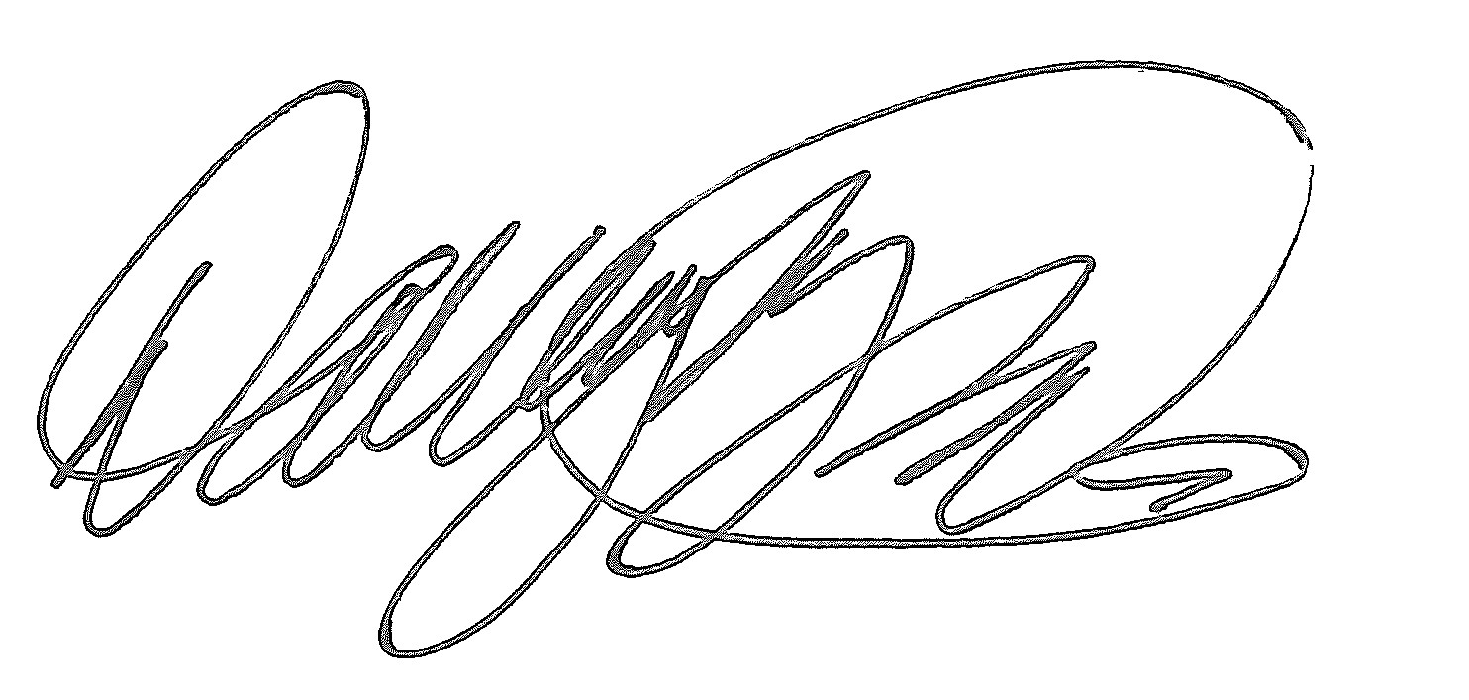
David Hoegberg
Associate Professor and Chair Department of English
The IU School of Liberal Arts IUPUI

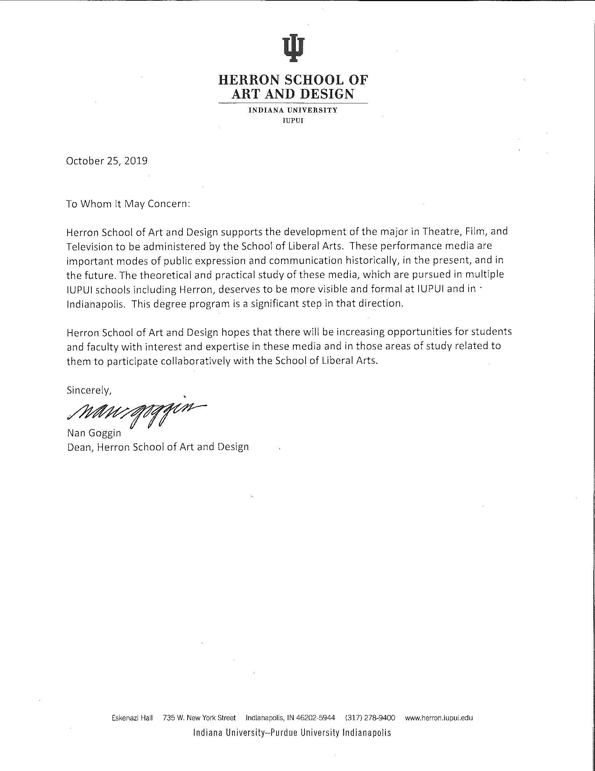

July 22, 2019

Robert Rebein, M.F.A., Ph.D.
Interim Dean and Professor of English Indiana University School of Liberal Arts IUPUI
Indianapolis, IN 46202 Dear Dean Rebein,
I write to express my support for the new Bachelor of Arts degree proposed by the School of Liberal Arts that is a combined Bachelor of Arts degree in Theater, Film, and Media Studies (TFMS).

I agree that TFMS has the potential to attract new students to IUPUI to take advantage of internships and other community engagement activities, which will be integrated with this exciting and innovative degree program.

My hope is this new degree program will provide additional opportunities for partnering with the School of Engineering and Technology at IUPUI to create minors, focus areas, and dual degree programs. I immediately see opportunities for partnering with several of our programs including music technology and computer graphics technology, among other programs.

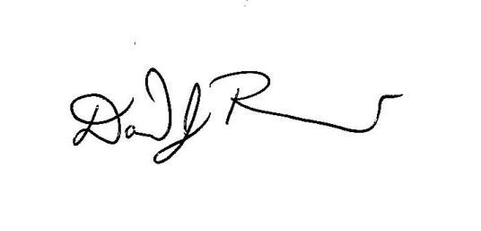
Best wishes for the successful implementation of this new program. Sincerely,

David J. Russomanno, Ph.D.
Dean, School of Engineering and Technology, IUPUI

  - Karen Alfrey, Ph.D., Associate Dean for Undergraduate Academic Affairs and Programs, E&T Deb Burns, Ph.D., Chair, Music and Arts Technology, E&T
Feng Li, Ph.D., Chair, Computer Information and Graphics Technology, E&T

799 West Michigan Street, Indianapolis, IN 46202-5160 (317) 274.0802 fax (317) 274.4567 drussoma@iupui.edu www.engr.iupui.edu

Indiana University-Purdue University Indianapolis

October 16, 2019
Margaret Ferguson, Ph.D.
Senior Associate Vice Chancellor for Academic Affairs, IUPUI 301 University Blvd., AD 5002
Indianapolis, IN 46202 Dear Margie,
The Indiana University School of Informatics and Computing (SOIC) would like to express its unreserved support for the preproposal for a Bachelor of Art in Theater, Film, and Television from the Indiana University School of Liberal Arts (SLA) at IUPUI. The curriculum has three tracks and includes courses from SOIC and the Herron School of Art and Design.
Our faculty anticipate that the degree will serve student by presenting an integrated curriculum of related courses that were previously less visible because they belong to different programs. We are confident that the inclusion of our video production courses, which we are also proposing as a minor, will enhance the career prospects of graduates of the new degree. Our school appreciates having the opportunity to collaborate in the development of the preproposal and looks forward to a continued productive collaboration on the proposed degree with SLA and Herron.

Respectfully,
Mathew Palakal, Ph.D.
Senior Executive Associate Dean Indiana University
School of Informatics and Computing 535 West Michigan St., IT 559 Indianapolis, IN 46202 USA
Tel: 317 278-8169
Email: mpalakal@iupui.edu
Web: https://soic.iupui.edu/people/mathew-palakal/

IT 559, 535 West Michigan Street, Indianapolis, IN 46202 USA

January 25th, 2020

Attn: Robert Rebein, Ph.D.

Dean, IU School of Liberal Arts IUPUI

Cavanaugh Hall (CA) 439

425 University Boulevard Indianapolis, IN 46202

Dear Dr. Rebein,

The prospect of adding an Interdisciplinary Major in Applied Theatre to the established and respected School of Liberal Arts at IUPUI as part of Communication Studies has been brought to my attention by Emilio Robles and I must say I am thrilled.

Please allow me to take a few moments to adequately express my enthusiasm and support of such a carefully considered field of study as it relates to today’s world and the education of young minds seeking to make a difference in their lives, their communities, and their global homes.

The Indianapolis Arts community is thriving, and this is the time to take advantage of that momentum. There have been several exciting, professional additions to the theatre and arts community within the past ten years which have served to increase Indianapolis’ attractiveness to professionals.

As an Indiana native, I grew up with an understanding of the performance opportunities in Indianapolis. While artistically well-developed and poignant, I knew the opportunities were limited. Indianapolis was not synonymous with a destination for theatre professionals who sought to make a career out of their creative pursuits. If I wanted to have a career in the arts, I would have to leave Indiana. I left to pursue an education and professional career because at the time it was relevant to me, it was the right decision. This landscape is changing!

Now, after 12 years of professional experience as a performer, creator, writer, and educator, I find myself back in Indiana and undeniably floored by the way the city has blossomed. There are several new semi-professional and professional companies creating powerful productions and educational opportunities, all of which, would be at the fingertips of IUPUI students to take advantage of as a part of their studies.

And, I would be remiss to not mention the ever growing concern of the graduate. Where will I work? How will I work? What can I do with my degree? Is a degree in an artistic field a wise choice? It is my strong opinion that a degree in Applied Theatre Studies would offer students of the program a unique perspective on how to utilize a performance degree to their advantage, gain real world experience, and understand the vast possibilities of how a degree of this nature could be applied to many areas of professional work.

As a working artist, I had to learn for myself that, in addition to the time I spent on the stage or on the screen, I would also have to supplement my income. Through my professional pursuits, I learned the skills I developed in theatrical study prepared me for a vast world of other professional opportunities: teaching, grant writing, management, event coordination, and many more.

The attractive thing about a degree in Applied Theatre is that it not only covers opportunities within the field of performance but highlights skillsets that are equally beneficial in other career fields.

Theatre practitioners learn, not only, how to perform in shows and analyze text. We learn how to adapt, how to empathize, how to teach, how to write, how to organize, how to run a business; and, a degree that focuses on these attributes, in addition to creating daring and thought provoking theatre, will allow students at IUPUI to make a difference in the world in whatever capacity they chose. They will learn not only how to create but also how to think.

Theatre artists challenge a community to reflect on themselves and their actions, as well as invite them to think about things beyond the everyday. It is my firm belief as an artist and educator that the more opportunities we provide students to develop these skills, the more conscious citizens of the world we create. IUPUI seeks to “create and exchange knowledge that promotes the understanding of the human experience” and what better field of study than the theatrical arts which inherently and historically champions the same cause.

An investment in an Interdisciplinary Major in Applied Theatre at IUPUI is an investment in a more creatively innovative and inclusive Indianapolis community.

All the best,

Maria Souza

Lecturer in Theatre at Purdue University

Actor | Writer | Creator

msouza@purdue.edu

Robert Rebein, Ph.D. Dean,

IU School of Liberal Arts IUPUI

Cavanaugh Hall (CA) 439

425 University Boulevard Indianapolis, IN 46202

Dear Dr. Robert Rebein:

I write to you as a longtime contributor to the ever-expanding Indianapolis theater scene. Though my work and studies in theater took me to New York and Chicago for more than a decade, I am proud to be firmly rooted now in my hometown of Indy with the formation of my own company, American Lives Theatre (ALT). This nonprofit is the result of years of planning and collaboration, and I am pleased to see our first season enjoying more attendance and attention than I would have anticipated for a new, small arts organization.

It was several months ago, prior to the opening of our first production, that I was fortunate to become acquainted with Visiting Professor Emilio Robles, whose enthusiasm, generosity and forward energy struck me immediately in our first meeting. I was seeking a mutually beneficial collaboration between IUPUI theater students and ALT, and this partnership has already yielded fruitfully in a variety of ways. During our initial meetings, Emilio spoke of a desire among students at IUPUI for more advanced theater courses and opportunities. This excited me on many levels, and being a former IU-Bloomington theater major myself, I was reminded of the thrill I felt being in the theater building on campus surrounded by so many professors and students of various theatrical disciplines. The community and coursework were wonderfully inseparable.

Two decades later, I see many of my classmates doing big things: currently Elizabeth Stanley is the star of 'Jagged Little Pill' on Broadway, Arian Moayed is in 'Succession' on HBO, Ansley Valentine has returned to IU teaching a new generation of young theater lovers, and countless others are like myself, happily plugging away across the country in this unpredictable business, using skills and knowledge we developed so long ago in a basement studio. And then there are those who went a completely different route - lawyers, doctors, a pilot, a novelist - all friends of mine who started their paths with a theater major from IU Bloomington.

American Lives Theatre • 9124 Hawkins Road, Indianapolis, IN 46216 • 317.623.3006

I don't need to tell you, an academic, the value of a theater major, but it is striking to me that the major that all of our parents warned us about has proven to be such a launching pad for such varied and interesting adult lives. And as someone who hires younger people in a variety of positions today, it fills me with pride that theater students are among the most driven and synergistic young minds I meet today. Of course I represent those who would provide actual theater jobs. In the past few months I've hired designers, actors, crew, and a dramaturg all having just completed or currently enrolled in Indiana theater programs. But there are many companies outside of the arts who seek a creative, collaborative mind. I can name at least five actors currently employed at Salesforce.

When we auditioned for our first season, the response among young people was staggering. There was simply no way we could have auditioned that many actors in two days. And after communicating with each of them, it became clear that there is a surge of Indy residents committed to the arts for professional development and personal fulfillment. And many of these younger people are hungry for training. My company is planning to develop our own education department next year, offering a variety of theater classes. But nothing can replace the collegiate theater training, learning your craft among your peers and having the safe space to fail and try again.

I hope IUPUI will respond to this hunger for more arts education. I respectfully ask you - from the standpoint of a professional theater maker, a proud Indy resident, a hiring manager, and a former theater major - to please consider the proposal Emilio and Kristine Karnack have brought to you. The city and its residents will be richly rewarded.

Very Sincerely,

Chris Saunders

Artistic Director

American Lives Theatre

January 30, 2020
Robert Rebein, Ph.D.
Dean, IU School of Liberal Arts IUPUI
Cavanaugh Hall (CA) 439
425 University Boulevard
Indianapolis, IN 46202

Dear Robert,

I am very excited about the prospect of an Interdisciplinary Major in Applied Theater at IUPUI. As the Producing Director at the Phoenix Theatre for 35 years and currently at the Fonseca Theatre Company (FTC), I have watched theater develop in Indianapolis for over 40 years. No local company has been more current in theater trends and models in the program area you are considering. It would be revolutionary in Indy and is long overdue.

I met with Emilio Robles to learn more about applied theater and check my assumptions. I found him to be highly engaging and competent. I am confident that he can develop a successful and much needed program at IUPUI. Some of us have experimented in devised work, conflict resolution, and therapy-related theater applications but it seems to me that applied theater combines elements of all three. Furthermore, we at the FTC believe that theater serves a greater purpose than mere entertainment. Again, applied theater achieves specific results and has a mission which encompasses education.

It is beneficial for our organization to draw from a new workforce of artists with this training to help us expand the range of services offered by FTC. We plan to use applied theater artists as patients, jurors, clients, teachers and/or students and corporate workers to train doctors, lawyers, etc., to approach scenarios with strategic conflict resolution, and to guide conversations on more sensitive topics such as bullying, sexual harassment, and equity, diversity and inclusion. Of course, this also improves the quality of life in our community as more people are “woke” to these issues.

The industry of theater is evolving as the country is pushed in new directions. Inclusivity and ethical behavior have been long overlooked and overdue as the new priority. Theater artists are uniquely positioned to assist in bringing awareness to these issues and there will be significant opportunities for artists with training in applied theater.

For these reasons, and so many others, I am in total support of this program and we would be receptive to collaborating in any way you might find beneficial. We have worked for many years developing community and corporate relationships. We also provide employment opportunities through our productions and programs. I’ve attached our mission and vision statements to give you a better sense of or values and community engagement. Please do not hesitate to contact me if you have any questions and thank you for giving Mr. Robles’ proposal your full consideration.

Sincerely,

Bryan Fonseca
Producing Director

Appendix 6: Faculty and Staff

Full-Time faculty, 2019-2020 (alphabetical)

Ronda C. Henry Anthony, Associate Professor of English and Africana Studies (Ph.D., Loyola University Chicago, 2004)
Areas of research and/or teaching specialization: American Literature/Studies; African, African-American, and American Literature; Gender Studies; Caribbean Studies. Courses in Africana Studies including Deconstructing Barbie, Hip Hop, Race and Gender, and Africana Studies Research Methods.

Dan Baldwin, Clinical Assistant Professor and Director, Computer Graphics Technology (MFA, Illustration, Savannah College of Art and Design, 2000)
Areas of research and/or teaching specialization: Illustration; Digital Painting; Animation Preproduction. Interests in video game history; Visual effects history; Digital media and popular culture.

Mark Bannatyne, Associate Professor, Computer Graphics Technology (Ph.D., Purdue University, 1995)
Areas of research and/or teaching specialization: Technology education; computer graphics; technology’s impact on society; historical aspects of social change due to technology; computer graphics education in the republics of the former Soviet Union.

Dennis Bingham, Professor of English and Director of the Film Studies Program (Ph.D., Ohio State University, 1990)
Areas of research and/or teaching specialization: Film studies; Film theory; Gender theory; American film genres; Artists and history; Film biography and stardom and acting.

Jonas Bjork, Professor and Chair of Journalism and Public Relations (Ph.D., University of Washington, 1987)
Areas of research and/or teaching specialization: Immigrant press in the United States; presence of U.S. mass media in Europe; History of foreign correspondence in the American press; International journalism organizations.

Andre Buchenot, Associate Professor of English (Ph.D., University of Wisconsin-Milwaukee, 2010)
Areas of research and/or teaching specialization: Critical literacy studies; Digital literacy; Science and technology studies; visual rhetorics/multimodal composing.

Jonathan Greenhoe, Digital Media Production Supervisor, IU School of Liberal Arts (M.A., Central Michigan University, 2009)
Areas of research and/or teaching specialization: Teaching interests include Studio video production; Live multi-camera production; Sports production; Post-production editing; Audio recording, podcasting and editing.

Jason Guy, Lecturer in Computer Graphics Technology (M.S., Purdue University)
Teaching specialization: environment art; gaming.

Raymond J. Haberski, Jr., Professor of American Studies and History; Director of the American Studies Program and Director of the Institute for American Thought (Ph.D., Ohio University, 1999)
Areas of research and/or teaching specialization: U.S. Intellectual History; American Studies; American cultural history; American religious history; History of movie culture. Teaching interests in 20th Century U.S. history; U.S. intellectual history; American Studies; Movies and American culture; American cultural history.

Krista Hoffmann-Longtin, Assistant Professor of Communication Studies; Assistant Dean of the Indiana University School of Medicine (Ph.D., Indiana University, 2014)
Areas of research and/or teaching specialization: Communication Pedagogy; Faculty development. Teaching interests in Communicating Science; Media Theory and Criticism.

Kristine Brunovska Karnick, Associate Professor and Chair of Communication Studies (Ph.D., University of Wisconsin-Madison, 1991)
Areas of research and/or teaching specialization: Mass media and society; Film and television history; film and television aesthetics and criticism; Media humor and comedy; film comedy; Early television history. Teaching interests in Television history; film history; film and television comedy; Media literacy; Television aesthetics and criticism; Media and society; Film and video documentary.

John C. King, Lecturer in Media Arts and Science (M.S., Ball State University, 2004)
Areas of research and/or teaching specialization: Teaching interests in Foundations of New Media; Digital Storytelling; Introduction to Digital Video; Scriptwriting; Advanced Scriptwriting for New Media.

Pamela C. Laucella, Assistant Professor of Journalism and Public Relations (Ph.D., University of North Carolina, 2004)
Areas of research and/or teaching specialization: Sports Communication

C. Thomas Lewis, Senior Lecturer in Media Arts and Science (M.F.A., California Institute of the Arts, 1993)
Areas of research and/or teaching specialization: Documentary filmmaking; Narrative filmmaking; Video-mapping/visualization; Narrative medicine; Health information systems and technologies. Teaching interests in Digital Video, Directorial Analysis, Production, and RAW Workflow; Lighting and Field Production; Digital Effects, Digital Cinema; Video for social change.

Steve Mannheimer, Professor of Media Arts and Science (M.F.A., Washington University, St. Louis, 1974)
Areas of research and/or teaching specialization: innovative design strategies for tactile graphics for the blind and visually impaired. Teaching interests in Creative concept development.

Kyle Minor, Associate Professor of English (M.F.A., Iowa Writers’ Workshop, 2013; M.F.A., The Ohio State University, 2007)
Areas of research and/or teaching specialization: Fiction writing; Narrative nonfiction; Poetry; Screenwriting; Playwriting; 20th and 21st Century American literature; Haitian diasporic literature; Southern Literature. Teaching interests in Fiction writing; Screenwriting; Playwriting; Literary Editing and publishing.

Malcolm Moran, Director, Sports Capital Journalism Program (B.A. Fordham University)
Areas of research and/or teaching specialization: Sports journalism.

Nichole Neuman, Assistant Professor of German (Ph.D., University of Minnesota, 2016)
Areas of research and/or teaching specialization: 20th and 21st century German and German-American cultural studies; cinema studies; German Cinema; cinema archives; representations of identity.

Josh Polk, Lecturer in Computer Graphics Technology (M.S., Purdue University)
Teaching specialization: graphic design, game programming, animation, UI/UX, drawing, web design and development, multimedia.

Trevor Potts, Lecturer in Communication Studies (M.A., University of Dayton, 1995)
Areas of research and/or teaching specialization: Teaching interests in Mass media and society; Communication Theory; Communication and social movements.

Emilio Robles, Lecturer in Communication Studies (M.F.A., University of Pittsburgh, 1999)
Areas of research and/or teaching specialization: Teaching interests in cultural literacy, multi-disciplinary arts integration; Theatre; Acting; Play directing; Rehearsal and performance; Play Devising, Community Outreach, Spanish and French Dramatic Literature, Teacher Education.

Christian Rogers, Associate Professor, Computer Graphics Technology (Ph.D., University of Toledo)
Areas of research and/or teaching specialization: media theory; experiential learning and pervasive technology in STEM education; teaching in video production; advanced motion design.

Sherra L. Schick, Visiting Assistant Professor of Film Studies
Areas of research and/or teaching specialization:

Michael E. Scott, Director of Technical Services, IU School of Liberal Arts
Areas of research and/or teaching specialization: Arts and technology; theatre; audio production; Theatrical lighting.

Appendix 7: Facilities

There is no specialized instructional space being requested. Almost all courses in the major are already being taught. They are being taught in appropriate spaces, laboratories, and other facilities.

Appendix 8: Other Capital Costs

No other capital costs associated with the program are anticipated.

Appendix 9: Articulation of Associate/Baccalaureate Programs

AGREEMENT BETWEEN
IVY TECH COMMUNITY COLLEGE AND
IUPUI FOR THE TRANSFER OF CREDITS EARNED IN THE
ASSOCIATE OF ARTS IN LIBERAL ARTS
TO THE BACHELOR OF ARTS IN THEATRE, FILM, AND TELEVISION
FALL 2020

The purpose of this agreement is to provide a framework for the transfer of credits earned in the Associate of Arts in Liberal Arts at Ivy Tech Community College (ITCC) into the Bachelor of Arts in Communication Studies – Theatre, Film, and Television Theatre Concentration at IUPUI.

The faculty of both institutions have worked together to develop the attached listings of course equivalencies, course requirements for the associate degree, and course requirements for the completion of the baccalaureate degree. The agreement applies to courses taken at ITCC beginning fall 2020. Courses covered by previous transfer agreements still in effect will transfer as specified in those agreements. All other course work taken prior to fall 2020 will be evaluated by the faculty of IUPUI to determine transferability. A maximum of 64 community college credits may be applied toward the Bachelor of Arts in Theatre, Film, and Television.

This agreement becomes effective when all signatures are affixed and remains in effect for two years from that date (of last signature). After two years, the agreement may be renewed with or without modification by mutual agreement of ITCC and IUPUI.

Both institutions agree to keep the other aware of curriculum changes as they occur. While both parties to the agreement understand its purpose is to maximize transfer opportunities for students, they also recognize that limits may be placed on courses accepted under the provisions of this agreement, should the student subsequently decide to change to another program not covered by the agreement. It is also understood that this articulation is unlikely to become a transfer statewide articulation pathway (TSAP), and that, if it does, this articulation would become invalidated in deference to the statewide agreement.

Agreed to November 18, 2019

For Ivy Tech Community College For IUPUI

Kara Monroe, Ph.D. Kathy Johnson, Ph.D.
Provost and Senior Vice President Executive Vice Chancellor and
of Academic Affairs Chief Academic Officer

Russell D. Baker, Ed.D. Rob Rebein, Ph.D.
Vice President for Academic Affairs Interim Dean, School of Liberal Arts
COLLEGEWIDE CURRICULUM OF RECORD
SCHOOL OF ARTS, SCIENCES & EDUCATION
LIBERAL ARTS
ASSOCIATE OF ARTS
PROGRAM CODE: LIBA
2020 - 2021
LOCATIONS:
Bloomington – Columbus – Evansville - Fort Wayne – Franklin – Greencastle – Indianapolis – Kokomo – Lafayette - Lake County – Lawrenceburg – Logansport – Madison – Marion - Michigan City - Muncie - Noblesville – Richmond – Sellersburg - South Bend/Elkhart - Terre Haute – Valparaiso – Wabash – ALSO AVAILABLE STATEWIDE VIA DISTANCE EDUCATION

DEGREE NOTES
The following suggested sequence includes all course requirements for this degree. You must consult with an academic advisor to determine which Transfer Cluster Electives should be chosen to receive the most credit at the receiving college or university.

Applied Theatre Concentration
Semester 1
A | ENGL 111 |  | English Composition | 3
 | IVYT 111 |  | Student Success in University Transfer | 1
A | COMM 101 |  | Fundamentals of Public Speaking (SL, required) | 3
A | MATH 123 |  | Quantitative Reasoning or Higher | 3-4
 | XXXX XXX |  | Foreign Language Elective | 3-4
 | XXXX XXX |  | Transfer Cluster Elective | 3
Total Semester Credit Hours: 16
Semester 2
 | ENGL 215 | Rhetoric and Argument |  |  | 3
A | XXXX XXX | Transfer General Education Core (TGEC) Elective |  |  | 3
 | XXXX XXX | Foreign Language Elective |  |  | 3-4
* | XXXX XXX | Transfer Cluster Elective |  |  | 3
A | XXXX XXX | Scientific Ways of Knowing Elective with lab component |  |  | 3-5
Total Semester Credit Hours: 15
Semester 3
A | HUMA 100 |  | Theatre Appreciation (Humanistic and Artistic Ways of Knowing Elective, required) |  |  |  | 3
A | XXXX XXX |  | Transfer General Education Core (TGEC) Elective |  |  |  | 3
A | XXXX XXX |  | Social and Behavioral Ways of Knowing Elective |  |  |  | 3
A | XXXX XXX |  | Transfer General Education Core (TGEC) Elective |  |  |  | 3
A | XXXX XXX |  | Transfer General Education Core (TGEC) Elective |  |  |  | 3
Total Semester Credit Hours: 15
Semester 4
^ | LIBA 279 |  | Liberal Arts Capstone Course |  |  | 1
** | XXXX XXX |  | Transfer Cluster Elective |  |  | 3
 | XXXX XXX |  | Humanistic and Artistic Ways of Knowing Elective |  |  | 3
*** | XXXX XXX |  | Transfer Cluster Elective |  |  | 3
 | XXXX XXX |  | Transfer Cluster Elective |  |  | 4
Total Semester Credit Hours: 14

Symbol Key
^ = Capstone Course
A = STGEC
AA Liberal Arts Total = 60 credits

*Must choose from FREN 201, SPAN 201, HIST 111, or HIST 112
**Must choose from FREN 202, SPAN 202, POLS 211, ANTH 154, or GEOG 207
***Must choose from ENGL 202, ENGL 203, ENGL 206, ENGL 214, ENGL 220, ENGL 221, ENGL 222, ENGL 223, PHIL 101, or PHIL 213

IUPUI Curriculum
Bachelor of Arts in Theatre, Film, and Television
Applied Theatre Concentration

Semester 5
COMM-M 150 | Mass Media and Contemporary Society |  | 3
COMM XXX | Production |  | 3
COMM-T XXX | Performance |  | 3
XXXX 300/400 | 300/400 Level Advanced Elective from Liberal Arts outside of Communication Studies |  | 3
XXXX 300/400 | Theory, History, Criticism |  | 3
Total Semester Credit Hours: 15
Semester 6
COMM-T 2XX | Fundamentals of Applied Theatre (New course) |  | 3
COMM 300/400 | 300/400 Level Production |  | 3
COMM-T 290 | Junior Internship Experience |  | 1
XXXX 300/400 | 300/400 Level Advanced Elective from Liberal Arts outside of Communication Studies |  | 3
XXXX XXX | Analytical Proficiency |  | 3
XXXX XXX | Elective |  | 2
Total Semester Credit Hours:15
Semester 7
COMM-T 437 | Creative Dramatics |  | 3
XXXX 300/400 | Theory, History, Criticism |  | 3
COMM-T 300/400 | 300/400 Level Performance |  | 3
XXXX 300/400 | 300/400 Level Advanced Elective |  | 3
XXXX 300/400 | 300/400 Level Advanced Elective from Liberal Arts outside of Communication Studies |  | 3
Total Semester Credit Hours: 15
Semester 8
XXXX 300/400 |  | Capstone: Independent Study Project, Senior Thesis, or Internship | 3
XXXX 300/400 |  | 300/400 Level Advanced Elective | 3
XXXX 300/400 |  | 300/400 Level Advanced Elective | 3
XXXX 300/400 |  | 300/400 Level Advanced Elective | 3
XXXX 300/400 |  | 300/400 Level Advanced Elective | 3
Total Semester Credit Hours: 15

Total Credit Requirement to earn BA in Bachelor of Arts in Theatre, Film, and Television:
Applied Theatre Concentration = 120 credits

Film and Television Studies Concentration

Semester 1
A | ENGL 111 |  | English Composition | 3
 | IVYT 111 |  | Student Success in University Transfer | 1
A | COMM 101 |  | Fundamentals of Public Speaking (SL, required) | 3
A | MATH 123 |  | Quantitative Reasoning or Higher | 3-4
 | XXXX XXX |  | Foreign Language Elective | 3-4
 | XXXX XXX |  | Transfer Cluster Elective | 3
Total Semester Credit Hours: 16
Semester 2
 | ENGL 215 | Rhetoric and Argument |  |  | 3
A | XXXX XXX | Transfer General Education Core (TGEC) Elective |  |  | 3
 | XXXX XXX | Foreign Language Elective |  |  | 3-4
* | XXXX XXX | Transfer Cluster Elective |  |  | 3
A | XXXX XXX | Scientific Ways of Knowing Elective with lab component |  |  | 3-5
Total Semester Credit Hours: 15
Semester 3
A | VISC 105 |  | Video and Sound |  |  |  | 3
A | XXXX XXX |  | Transfer General Education Core (TGEC) Elective |  |  |  | 3
A | XXXX XXX |  | Social and Behavioral Ways of Knowing Elective |  |  |  | 3
A | XXXX XXX |  | Transfer General Education Core (TGEC) Elective |  |  |  | 3
A | XXXX XXX |  | Transfer General Education Core (TGEC) Elective |  |  |  | 3
Total Semester Credit Hours: 15
Semester 4
^ | LIBA 279 |  | Liberal Arts Capstone Course |  |  | 1
** | XXXX XXX |  | Transfer Cluster Elective |  |  | 3
 | XXXX XXX |  | Humanistic and Artistic Ways of Knowing Elective |  |  | 3
*** | XXXX XXX |  | Transfer Cluster Elective |  |  | 3
 | XXXX XXX |  | Transfer Cluster Elective |  |  | 4
Total Semester Credit Hours: 14

Symbol Key
^ = Capstone Course
A = STGEC
AA Liberal Arts Total = 60 credits

*Must choose from FREN 201, SPAN 201, HIST 111, or HIST 112
**Must choose from FREN 202, SPAN 202, POLS 211, ANTH 154, or GEOG 207
***Must choose from ENGL 202, ENGL 203, ENGL 206, ENGL 214, ENGL 220, ENGL 221, ENGL 222, ENGL 223, HUMA 100, PHIL 101, or PHIL 213

IUPUI Curriculum
Bachelor of Arts in Theatre, Film, and Television
Film and Television Studies Concentration

Semester 5
COMM-M 150 | Mass Media and Contemporary Society |  | 3
FILM-C 292 | Introduction to Film |  | 3
COMM-M 215 | Media Literacy |  | 3
XXXX 300/400 | 300/400 Level Advanced Elective from Liberal Arts outside of Communication Studies |  | 3
XXXX 300/400 | Theory, History, Criticism |  | 3
Total Semester Credit Hours: 15
Semester 6
XXXX 300/400 | Theory, History, Criticism |  | 3
XXXX 300/400 | Cultural Approaches |  | 3
XXXX XXX | Creative Expression |  | 3
XXXX 300/400 | 300/400 Level Advanced Elective from Liberal Arts outside of Communication Studies |  | 3
XXXX XXX | Analytical Proficiency |  | 3
Total Semester Credit Hours:15
Semester 7
XXXX 300/400 | Theory, History, Criticism |  | 3
XXXX 300/400 | Cultural Approaches |  | 3
XXXX 300/400 | 300/400 Level Advanced Elective |  | 3
XXXX 300/400 | 300/400 Level Advanced Elective |  | 3
XXXX 300/400 | 300/400 Level Advanced Elective from Liberal Arts outside of Communication Studies |  | 3
Total Semester Credit Hours: 15
Semester 8
XXXX 300/400 |  | Capstone: Independent Study Project, Senior Thesis, or Internship | 3
XXXX 300/400 |  | 300/400 Level Advanced Elective | 3
XXXX 300/400 |  | 300/400 Level Advanced Elective | 3
XXXX 300/400 |  | 300/400 Level Advanced Elective | 3
XXXX XXX |  | Elective | 3
Total Semester Credit Hours: 15

Total Credit Requirement to earn BA in Bachelor of Arts in Theatre, Film, and Television:
Film and Television Studies Concentration = 120 credits

Integrated Film and Television Studies/Production Concentration

Semester 1
A | ENGL 111 |  | English Composition | 3
 | IVYT 111 |  | Student Success in University Transfer | 1
A | COMM 101 |  | Fundamentals of Public Speaking (SL, required) | 3
A | MATH 123 |  | Quantitative Reasoning or Higher | 3-4
 | XXXX XXX |  | Foreign Language Elective | 3-4
 | XXXX XXX |  | Transfer Cluster Elective | 3
Total Semester Credit Hours: 16
Semester 2
 | ENGL 215 | Rhetoric and Argument |  |  | 3
A | XXXX XXX | Transfer General Education Core (TGEC) Elective |  |  | 3
 | XXXX XXX | Foreign Language Elective |  |  | 3-4
* | XXXX XXX | Transfer Cluster Elective |  |  | 3
A | XXXX XXX | Scientific Ways of Knowing Elective with lab component |  |  | 3-5
Total Semester Credit Hours: 15
Semester 3
A | VISC 105 |  | Video and Sound |  |  |  | 3
A | XXXX XXX |  | Transfer General Education Core (TGEC) Elective |  |  |  | 3
A | XXXX XXX |  | Social and Behavioral Ways of Knowing Elective |  |  |  | 3
A | XXXX XXX |  | Transfer General Education Core (TGEC) Elective |  |  |  | 3
A | XXXX XXX |  | Transfer General Education Core (TGEC) Elective |  |  |  | 3
Total Semester Credit Hours: 15
Semester 4
^ | LIBA 279 |  | Liberal Arts Capstone Course |  |  | 1
** | XXXX XXX |  | Transfer Cluster Elective |  |  | 3
 | XXXX XXX |  | Humanistic and Artistic Ways of Knowing Elective |  |  | 3
 | ENGL 202 |  | Creative Writing |  |  | 3
 | XXXX XXX |  | Transfer Cluster Elective |  |  | 4
Total Semester Credit Hours: 14

Symbol Key
^ = Capstone Course
A = STGEC
AA Liberal Arts Total = 60 credits

*Must choose from FREN 201, SPAN 201, HIST 111, or HIST 112
**Must choose from FREN 202, SPAN 202, POLS 211, ANTH 154, or GEOG 207

IUPUI Curriculum
Bachelor of Arts in Theatre, Film, and Television
Integrated Film and Television Studies/Production Concentration

Semester 5
COMM-M 150 | Mass Media and Contemporary Society |  | 3
FILM-C 292 OR COMM-M 215 | Introduction to Film OR Media Studies |  | 3
XXXX 300/400 | 300/400 Level Advanced Elective |  | 3
XXXX 300/400 | 300/400 Level Advanced Elective from Liberal Arts outside of Communication Studies |  | 3
XXXX XXX | Production |  | 1
XXXX XXX | Elective |  | 2
Total Semester Credit Hours: 15
Semester 6
FILM-C 391 OR COMM-M 462 | The Film: Theory and Aesthetics OR Television Aesthetics and Criticism |  | 3
XXXX 300/400 | Film and Television Arts |  | 3
XXX XXX | Production Planning |  | 3
XXXX 300/400 | 300/400 Level Advanced Elective from Liberal Arts outside of Communication Studies |  | 3
XXXX XXX | Analytical Proficiency |  | 3
Total Semester Credit Hours:15
Semester 7
ENG-W 302 | Screenwriting |  | 3
XXXX XXX | Production |  | 3
XXXX 300/400 | Production Process |  | 3
XXXX 300/400 | 300/400 Level Advanced Elective |  | 3
XXXX 300/400 | 300/400 Level Advanced Elective from Liberal Arts outside of Communication Studies |  | 3
Total Semester Credit Hours: 15
Semester 8
XXXX 300/400 |  | Production Capstone | 3
XXXX 300/400 |  | 300/400 Level Production | 3
XXXX 300/400 |  | Film Television and Arts | 3
XXXX 300/400 |  | 300/400 Level Advanced Elective | 3
XXXX 300/400 |  | 300/400 Level Advanced Elective | 3
Total Semester Credit Hours: 15

Total Credit Requirement to earn BA in Theatre, Film, and Television: Integrated Film and Television Studies/Production Concentration = 120 credits

Appendix 10: Credit Hours Required/Time to Completion

Major in Theatre, Film and Television (TFT)

Applied Theatre Concentration
The Applied Theatre concentration focuses on acting, directing, theatre history, playwriting, dramatic literature, and theatre design and technology. Students have the opportunity to participate in all aspects of theatre performance using theatre as a voice for social change.

Degree Requirements:
Minimum of 34 credit hours. The following are specific requirements for successful completion of the major:
  - Fundamentals (common to all concentrations): M150 Mass Media and Contemporary Society
  - Core courses: T130 Introduction to Theatre OR L203 Introduction to Drama; T2XX: Fundamentals of Applied Theatre; C437: Creative Dramatics
  - 6 credit hours of theatre production
  - 6 credit hours of performance courses
  - 6 credit hours in Theory-History-Criticism. At least 3 hours must be at the 300 level or above.
  - 1 credit hour Junior Internship Bridge Experience
  - 3 credit hour Capstone experience (common to all concentrations)
  - At least 15 credit hours in the major must be in courses at the 300 level or above.
  - No more than 12 credit hours may transfer. At least 21 credit hours must be taken in courses specific to the program in Theatre
  - The student must earn a C or higher in all major course work.
  - No more than a total of 9 hours of combined Independent Study and Internship credit toward graduation.

1 course: Fundamentals
- COMM M150: Mass Media and Contemporary Society (3 cr.)

3 courses: Theatre Core
- COMM T130: Introduction to Theatre (3 cr.) or ENGL L203: Introduction to Drama
- COMM T2XX: Fundamentals of Applied Theatre (3 cr.)
- COMM T437: Creative Dramatics (3 cr.)

2 courses: Production
- COMM T100 Rehearsal and Performance (3-6 cr.)
- COMM T339 Play Directing (3 cr.)
- COMM T431 Playwriting (3 cr.)
- As program grows, reintroduce the following:
  - COMM C101 Stage Makeup
  - COMM C131 Stage Scenery
  - COMM C330 Stage Lighting

  - COMM C331 Advanced Stagecraft
  - COMM C332 Costuming for the Theatre
  - COMM C430 Theatre Management

courses: Performance
  - COMM T104 Voice for the Stage (3 cr.)
  - COMM T133 Introduction to Acting (3 cr.)
  - COMM T205 Introduction to Oral Interpretation (3 cr.)
  - COMM T3XX Theatre for Social Change (3 cr.)
  - COMM T333 Acting II (3 cr.)

2 courses: Theory-History-Criticism
  - WOST W300 Topics in Women’s Studies (with consent)
  - CLAS C310 Classical Drama (3 cr.)
  - ENG L315 Major Plays of Shakespeare (3 cr.)
  - COMM T337 History of Theatre I (3 cr.)
  - COMM T338 History of Theatre II (3 cr.)
  - ENG L365 Modern Drama: Continental (3 cr.)
  - ENG L366 Modern Drama: English, Irish, and American (3 cr.)
  - ENG L370 Recent Black American Writing (3 cr.)
  - ENG L379 Ethnic and Minority Literature of the United States (3 cr.)
  - ENG L406 Topics in African-American Literature (with consent) (3 cr.)
  - ENG L433 Conversations with Shakespeare (3 cr.)
  - COMM-R 478 Persuasion and Media in Social Movements (3 cr.)
  - MSTD A460 Museum Theatre (3 cr.)

1 course: Bridge Experience
- COMM T2XX Junior Internship experience (1 cr.)

1 course: Capstone
- The Capstone experience can be an independent study project, a senior thesis, or an internship project. (3 cr.)

*Other elective courses may be accepted with approval of the program director.

Film and Television Studies Concentration
Film and Television Studies focuses on the history, theory, criticism, cultural uses, and production practices of television, film, and media arts. Students are required to take one media production course in order to gain a concrete understanding of the possibilities of these media. Emphasis is on critical analysis, creative expression, and an understanding of how media functions in our society.

Degree Requirements:
Minimum of 33 credit hours. The following are specific requirements for successful completion of the major:
- Fundamentals (common to all concentrations): M150 Mass Media and Contemporary Society
- 2 Core courses: C292 Introduction to Film or M215 Media Literacy and
Film-C391: The Film - Theory and Aesthetics or COMM-M462: Television Aesthetics and Criticism
- One production course: M221 Electronic Media Production or NEWM N253: Introduction to Digital Video
- 9 credit hours in Theory-History-Criticism. At least 6 hours must be at the 300-level or above.
- 6 credit hours in cultural approaches
- 3 credit hours in creative methods
- 3 credit hour Capstone experience (common to both concentrations).
- At least 15 credit hours in the major must be in courses at the 300 level or above.
- No more than 12 credit hours may transfer. At least 21 credit hours must be taken in courses specific to the program in Film and Media Arts.
- A grade of C or higher in all major course work.
- No more than 9 hours of combined Independent Study and Internship credit toward graduation.

course: Fundamentals
  - COMM M150 Mass Media and Contemporary Society (3 cr.)

2 courses: Film and Television Studies Core (6 cr.)
  - FILM-C292 Introduction to Film or COMM-M215: Media Literacy (3 cr.)
  - FILM-C391 The Film: Theory and Aesthetics (3 cr.)
OR COMM-M462: Television Aesthetics and Criticism (3 cr.)

1 course: Production
- COMM M221 Electronic Media Production (3 cr.) or NEWM N253: Introduction to Digital Video (3 cr.)

3 courses: Theory-History-Criticism

MUS-Z315 Music for Film (3 cr.)
- FILM C350 Film Noir (3 cr.)
- FILM C351 Musicals (3 cr.)
- FILM C352 Biopics (3 cr.)
- PHIL P355 Philosophy of Film (3 cr.)
- FILM C361 Hollywood Studio Era 1930-1949 (3 cr.)
- FILM C362 Hollywood in the 1950s (3 cr.)
- COMM M370 History of Television (3 cr.)
- COMM M373 Film and Video Documentary (3 cr.)
- FILM C380 French Cinema (3 cr.)
- FILM C390 The Film and Society: Topics (3 cr.)
- FILM C391 The Film: Theory and Aesthetics (3 cr.)
- FILM C392 Genre Study in Film (3 cr.)
- FILM C393 History of European and American Films I (3 cr.)
- FILM C394 History of European and American Films II (3 cr.)
- COMM M462 Television Aesthetics and Criticism (3 cr.)
- JOUR J475 Race, Gender and the Media (3 cr.)
- COMM-R 478 Persuasion and Media in Social Movements (3 cr.)
- FILM C491 Authorship and Cinema (3 cr.)
- FILM C493 Film Adaptations of Literature (3 cr.)

2 courses: Cultural Approaches

COMM-C299 Communicating Queer Identity (3 cr.)
- WOST-A316 Women of the Diaspora: Race, Culture and Education (3 cr.)
- AFRO-A326 Race, Beauty, and Popular Culture (3 cr.)
- EALC-E334 Contemporary Chinese Cinema (3 cr.)
- COMM-R350 Women Speak: American Feminist Rhetoric (3 cr.)
- AMST-A363 American Cyber Identity (3 cr.)
- GER-G370 German Cinema (3 cr.)
- MHHS-M410 Addiction Narratives (3 cr.)
- MHHS-M420 The Culture of Mental Illness (3 cr.)
- FREN-F391 Studies in French Cinema (Taught in French) (3 cr.)
- FREN-F460 French Fiction in Film (Taught in French) (3 cr.)
- COMM-C482 Intercultural Communication (3 cr.)

1 course: Creative Expression
- COMM-T133 Acting I (3 cr.)
- COMM-M210 Media Message Design (3 cr.)
- COMM-M464 Podcasting, Radio and Sound Production (3 cr.)
- ENG-W260 Writing of Film Criticism (3 cr.)
- ENG-W302 Screenwriting (3 cr.) (prerequisite: W206)
- ENG-W315 Writing for the Web (3 cr.)
- ENG-W318 Finding your E-voice (3 cr.)
- JOUR-J321 Principles of Public Relations (3 cr.)

1 course: Capstone
- The Capstone experience can be an independent study project, a senior thesis, or an internship project. (3 cr.)

*Other elective courses may be accepted with approval of the program director.

Integrated Film and Television Studies/Production Concentration
The Integrated Film and Television Studies/Production concentration emphasizes an understanding and appreciation of the art of film and television, within a firm working knowledge of the processes of production. The emphasis in this concentration is on the application of theoretical concepts, critical analysis, and historical understanding to a production context. Students will apply their knowledge of film and television studies to the construction of media projects.

Degree Requirements:
37 credit hours. The following are specific requirements for successful completion of the major:
- Fundamentals (common to the three concentrations): M150 Mass Media and Contemporary Society
- Core courses: Either FILM-C292: Introduction to Film or COMM-M215: Media Literacy AND either FILM-C391: The Film: Theory and Aesthetics OR COMM-M462: Television Aesthetics and Criticism
- 6 credit hours of Film and Television Arts Electives
- 3 credit hours of ENG-W302: Screenwriting
- 3 credit hours in Production Planning
- 6 credit hours in Production Process: NEWM-N253: Introduction to Digital Video or COMM-M221: Electronic Media Production, AND NEWM-N353: Intermediate Digital Video or HER K300: Time-Based Art (Advanced Digital Imaging)
- 7 credit hours of Production Electives
- 3 credit hour Capstone experience (common to all three concentrations)
- At least 18 credit hours in the major must be in courses at the 300 level or above.
- Residency Requirement: No more than 15 credit hours may transfer. At least 24 credit hours must be taken in courses specific to the program in Film and Television as defined in this curriculum..
- A grade of C or higher in all major course work.
- No more than 9 hours of combined Independent Study and Internship credit toward graduation.

course: Fundamentals (3 cr.)
  - COMM-M150: Mass Media and Contemporary Society (3 cr.)

courses: Film and Television Arts Core (6 cr.)
  - FILM-C292 Introduction to Film or COMM-M215: Media Literacy (3 cr.)
  - FILM-C391 The Film: Theory and Aesthetics (3 cr.)
OR COMM-M462: Television Aesthetics and Criticism (3 cr.)

courses: Film and Television Arts Electives (6 cr.)

MUS-Z315 Music for Film (3 cr.)
- FILM-C351 Musicals (3 cr.)
- FILM-C352 Biopics (3 cr.)
- FILM-C361 Hollywood Studio Era 1930-1949 (3 cr.)
- FILM-C362 Hollywood in the 1950s (3 cr.)
- COMM-M370 History of Television (3 cr.)
- COMM-M373 Film and Video Documentary (3 cr.)
- COMM-G391 Variable Title Seminar (media-related topic only) (3 cr.)
- FILM-C380 French Cinema (3 cr.)
- FILM-C390 Topics in Film (Variable Title) (3 cr.)
- FILM-C392 Genres in Film (Variable Title) (3 cr.)
- FILM-C393 History of European and American Films I (3 cr.)
- FILM-C394 History of European and American Films II (3 cr.)
- FILM-C491 Authorship in Cinema (Variable Title) (3 cr.)
- FILM-C493 Film Adaptations of Literature (3 cr.)

1 course: Scriptwriting (3 cr.)

COMM-M210 Media Message Design (3 cr.) OR

ENG-W250 Writing in Context (with appropriate topic) (3 cr.) OR
- ENG-W302 Screenwriting (3 cr.) (pre-requisite: W206 can be taken to fulfill partly the General Education Arts and Humanities requirement)

1 course: Production Planning (3 cr.)
  - HER-A307 Concepts in Action: Concept Art and Illustration (3 cr.) OR
  - NEWM-N420 Multimedia Project Development (3 cr.) OR
  - CGT 31800 Animation Preproduction (3 cr.) (prerequisite: CGT 20100)

courses: Production Process (6 cr.)
- COMM-M221: Electronic Media Production (3 cr.) OR
NEWM-N253* Introduction to Digital Video (3 cr.) OR
CGT 20200 Motion and Video 1 (3 cr.)
AND
- COMM-M465 Advanced Video Technique (3 cr.) (prerequisite: NEWM-N253 or COMM-M221) OR
NEWM-N353*Intermediate Digital Video (3 cr.) (prerequisite: NEWM-N253 or COMM- M221, or instructor consent) OR
CGT 34600 Digital Video and Audio (3 cr.) (prerequisite: CGT 20100 or Comm-M221)

* Course content in N253 and N353 alternates (fall/spring semesters) between narrative and documentary video

courses: Production Electives (7 cr.)
  - MUS-A132 Music Technology Lab I (3 cr.)
  - MUS-A142 Music Technology Lab II (3 cr.) (prerequisite: A132)
  - COMM-M220 Electronic Graphic Production (3 cr.)
  - NEWM-N255 Introduction to Digital Sound (3 cr.)
  - COMM-M290 Video Production Workshop (1 cr.)
  - COMM-G300 Independent Study (1-3 cr.)
  - HER K300 Time-Based Art (Advanced Digital Imaging) (3 cr.) (prerequisite: HER-K301 or HER-K303)
  - HER-A307 Illustration for Animators (3 cr.)
  - CGT 31400 Advanced Motion Design (3 cr.)
  - NEWM-N340 Motion Graphics (3 cr.)
  - CGT 35100 Interactive Multimedia Design (3 cr.) (prerequisite: CGT 25100)
  - NEWM-N354 Directorial Analysis, Production, and RAW Workflow (3 cr.) (prerequisite: NEWM-N253)
  - NEWM-N356 Lighting and Field Production (3 cr.) (prerequisite: NEWMN-253 and NEWMN-N353)
  - NEWM-N357 Digital Effects (3 cr.) or
CGT 44400 History and Technique of Visual Effects in Film (3 cr.)
  - CGT 40200 Motion and Video 2 (3 cr.) (prerequisite: CGT 34600)
  - CGT 44200 Production for Computer Animation (3 cr.) (prerequisite: CGT 34100)
  - COMM-G491 Internship (1-6 cr.) or
  - HER-K430 Photography and Intermedia Seminar (when appropriate topic) (3 cr.)
  - NEWM-N453 Advanced Digital Video (3 cr.) or
CGT 44600 Technical Animation Production and Direction (3 cr.)
  - NEWM-N456 Digital Cinema (3 cr.)(prerequisite: NEWM-N253 and NEWM-N353 and NEWM-N354)
  - INFO-I459 Media and Technology Entrepreneurship (3 cr.)
  - COMM-M461 Production Problems in Communication Media (variable topic) (3 cr.)
  - COMM-M463 Advanced Graphic Technique (3 cr.)
  - COMM-M464 Advanced Audio Technique (3 cr.)
  - COMM-M465 Advanced Video Technique (3 cr.)
  - COMM-M466 Television Direction (3 cr.)

1 course: Capstone (3 cr.)
- TFT-P4XX: Proposed Production Capstone (3 cr.)

**Other appropriate courses may be acceptable in consultation with program director.

THEATRE, FILM AND TELEVISION BA Fall 2020 and Beyond Degree Map

APPLIED THEATRE Concentration

Fall Year 1 | Credit hours | Spring Year 1 | Credit hours
ENG-W 131 | 3 | COMM-R 110 | 3
World Language First Semester | 4 | World Language Second Semester | 4
Analytical Reasoning List A | 3 | Analytical Reasoning List A or B | 3
COMM-M 150 | 3 | COMM-T 130 or ENGL-L203 | 3
SLA-S 100 | 2 | Life and Physical Science | 3
Total credit hours: | 15 | Total credit hours: | 16

Fall Year 2  Milestone Meet with Career Advisor | Credit hours | Spring Year 2 Milestone Meet with Faculty Mentor | Credit hours
World Language or History | 3 | World Language or Global History and Perspectives | 3
Writing Proficiency | 3 | Analytical Proficiency | 3
Career Community | 1 | Life and physical science with lab | 3
COMM-T 2XX | 3 | Production | 3
General Education Core Social Science or Arts and Humanities | 3 | Theory, History, Criticism at 300/400 level | 3
Open Elective | 3
Total credit hours: | 16 | Total credit hours: | 15

Fall Year 3  Milestone Meet with Career Advisor | Credit hours | Spring Year 3 Milestone Meet with Faculty Mentor | Credit hours
Performance | 3 | COMM-T 437 | 3
Production at 300/400 level | 3 | Performance | 3
SLA Arts & Humanities | 3 | SLA 300/400 Level Elective | 3
SLA 300/400 Level Elective | 3 | SLA Social Science | 3
COMM-T 290 | 1 | 300/400 Level Elective | 3
Total credit hours: | 13 | Total credit hours: | 15

Fall Year 4  Milestone Meet with Career Advisor  Milestone Apply for Graduation | Credit hours | Spring Year 4 | Credit hours
Theory, History, Criticism at 300/400 level | 3 | COMM Capstone at 400 level | 3
300/400 Level Elective | 3 | Open Elective | 3
SLA 300/400 Level Elective | 3 | 300/400 Level Elective | 3
300/400 Level Elective | 3 | 300/400 Level Elective | 3
300/400 Level Elective | 3 | Open Elective | 3
Total credit hours: | 15 | Total credit hours: | 15

THEATRE, FILM AND TELEVISION BA Fall 2020 and Beyond Degree Map

FILM AND TELEVISION STUDIES Concentration

Fall Year 1 | Credit hours | Spring Year 1 | Credit hours
ENG-W 131 | 3 | COMM-R 110 | 3
World Language First Semester | 4 | World Language Second Semester | 4
Analytical Reasoning List A | 3 | Analytical Reasoning List A or B | 3
COMM-M 150 | 3 | FILM-C 292 | 3
SLA-S 100 | 2 | Life and Physical Science | 3
Total credit hours: | 15 | Total credit hours: | 16

Fall Year 2  Milestone Meet with Career Advisor | Credit hours | Spring Year 2 Milestone Meet with Faculty Mentor | Credit hours
World Language or History | 3 | World Language or Global History and Perspectives | 3
Writing Proficiency | 3 | Analytical Proficiency | 3
Career Community | 1 | Life and physical science with lab | 3
COMM-M 215 | 3 | COMM-M 221 | 3
General Education Core Social Science or Arts and Humanities | 3 | Cultural Approaches at 300/400 level | 3
Open Elective | 2
Total credit hours: | 15 | Total credit hours: | 15

Fall Year 3  Milestone Meet with Career Advisor | Credit hours | Spring Year 3 Milestone Meet with Faculty Mentor | Credit hours
Theory, History, Criticism at 300/400 level | 3 | Theory, History, Criticism at 300/400 level | 3
Creative Expression at 300/400 level | 3 | Theory, History, Criticism | 3
300/400 Level Elective | 3 | SLA 300/400 Level Elective | 3
SLA 300/400 Level Elective | 3 | SLA Social Science | 3
SLA Arts & Humanities | 3 | 300/400 Level Elective | 3
Total credit hours: | 15 | Total credit hours: | 15

Fall Year 4  Milestone Meet with Career Advisor  Milestone Apply for Graduation | Credit hours | Spring Year 4 | Credit hours
Cultural Approaches at 300/400 level | 3 | Capstone at 400 level | 3
300/400 Level Elective | 3 | Open Elective | 3
SLA 300/400 Level Elective | 3 | 300/400 Level Elective | 3
Open Elective | 3 | 300/400 Level Elective | 3
Open Elective | 3 | Open Elective | 2
Total credit hours: | 15 | Total credit hours: | 14

THEATRE, FILM AND TELEVISION BA Fall 2020 and Beyond Degree Map

INTEGRATED FILM AND TELEVISION STUDIES/PRODUCTION Concentration

Fall Year 1 | Credit hours | Spring Year 1 | Credit hours
ENG-W 131 | 3 | COMM-R 110 | 3
World Language First Semester | 4 | World Language Second Semester | 4
Analytical Reasoning List A | 3 | Analytical Reasoning List A or B | 3
COMM-M 150 | 3 | FILM-C 292 or COMM-M 215 | 3
SLA-S 100 | 2 | Life and Physical Science | 3
Total credit hours: | 15 | Total credit hours: | 16

Fall Year 2  Milestone Meet with Career Advisor | Credit hours | Spring Year 2 Milestone Meet with Faculty Mentor | Credit hours
World Language or History | 3 | World Language or Global History and Perspectives | 3
Writing Proficiency | 3 | Analytical Proficiency | 3
Career Community | 1 | Life and physical science with lab | 3
Production Process | 3 | FILM-C 391 | 3
ENG-W 206 | 3 | ENG-W 302 | 3
Open Elective | 2 | Production Elective | 1
Total credit hours: | 15 | Total credit hours: | 15

Fall Year 3  Milestone Meet with Career Advisor | Credit hours | Spring Year 3 Milestone Meet with Faculty Mentor | Credit hours
Production Planning | 3 | Production Process | 3
Film and Television Arts at 300/400 level | 3 | Production Elective | 3
General Education Core Social Science or Arts and Humanities | 3 | SLA 300/400 Level Elective | 3
SLA 300/400 Level Elective | 3 | SLA Social Science | 3
SLA Arts & Humanities | 3 | 300/400 Level Elective | 3
Total credit hours: | 15 | Total credit hours: | 15

Fall Year 4  Milestone Meet with Career Advisor  Milestone Apply for Graduation | Credit hours | Spring Year 4 | Credit hours
Production Elective | 3 | Capstone at 400 level | 3
300/400 Level Elective | 3 | Film and Television Arts at 300/400 level | 3
SLA 300/400 Level Elective | 3 | 300/400 Level Elective | 3
300/400 Level Elective | 3 | 300/400 Level Elective | 3
300/400 Level Elective | 3 | Open Elective | 2
Total credit hours: | 15 | Total credit hours: | 14

Appendix 11: Details Related to Exceeding the Standard Expectation of Credit Hours

The program will not exceed 120 semester credit hours.

IUPUI Undergraduate Affairs Committee January 4, 2019

